GCSE Biology Trilogy (F)
Required Practical Question Book

Name: | Class: | Teacher:

Practical 1  Microscopy | / 16 | Practical 4  Food Tests | / 14
Practical 2  Osmosis | / 11 | Practical 5  Photosynthesis | / 14
Practical 3  Enzymes | / 13 | Practical 6  Reaction Time | / 17
Practical 7  Field Investigations |  | / 13

Required Practical 1: Microscopy
Use a light microscope to observe, draw and label a selection of plant and animal cells.
- The image below shows some muscle cells from the wall of the stomach, as seen through a light microscope.

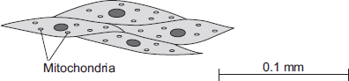

(a) Describe the function of muscle cells in the wall of the stomach.

___________________________________________________________________

___________________________________________________________________

(2)

(b) Figure above is highly magnified. The scale bar in Figure above represents 0.1 mm.

Use a ruler to measure the length of the scale bar and then calculate the magnification of Figure above.

___________________________________________________________________

___________________________________________________________________

Magnification = _______________ times

(2)

(c) The muscle cells in Figure above contain many mitochondria.

What is the function of mitochondria?

___________________________________________________________________

___________________________________________________________________

(2)

(d) The muscle cells also contain many ribosomes. The ribosomes cannot be seen in Figure above.

(i) What is the function of a ribosome?

______________________________________________________________

______________________________________________________________

(1)

(ii) Suggest why the ribosomes cannot be seen through a light microscope.

______________________________________________________________

______________________________________________________________

(1)

- The image below shows part of the surface of a leaf.

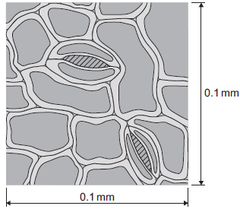

The length and width of this piece of leaf surface are both 0.1 mm.

(a) Calculate the number of stomata per mm² of this leaf surface.

______________________________________________________________

______________________________________________________________

_______________________ per mm²

(2)
- (a) The cheek cell in Figure 2 is magnified 250 times.

The width of the cell is shown by the line D to E.

Figure 2

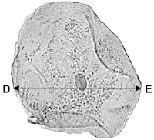

Calculate the width of the cheek cell in micrometres (µm).

Complete the following steps.

Measure the width of the cell using a ruler _____________________ mm

Use the equation to work out the real width of the cell in mm:

real size = 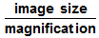 _____________________ mm

Convert mm to µm _____________________ µm

(3)

(b) A red blood cell is 8 µm in diameter.

A bacterial cell is 40 times smaller.

Calculate the diameter of the bacterial cell.

Tick one box.
0.02 µm
0.2 µm
2.0 µm
20.0 µm

(1)
- The photograph shows a red blood cell.

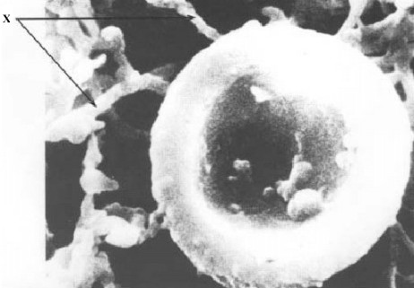

(a) The average diameter of a real red blood cell is 0.008 millimetres.
On the photograph, the diameter of the red blood cell is 100 millimetres.

Use the formula to calculate the magnification of the photograph.

Diameter on photograph = Real diameter × Magnification

___________________________________________________________________

___________________________________________________________________

Magnification = _______________________________

(2)

Required Practical 2: Osmosis
Investigate the effect of a range of concentrations of salt/sugar solutions on the mass of plant tissue.

- In fish and chip shops, potatoes are cut into chips several hours before they are cooked.

The amount of water in the chips must be kept constant during this time.

To keep the water in the chips constant, the chips are kept in salt solution.

A student investigated the effect of different concentrations of salt solution on the mass of chips.

• He weighed each of five chips.

• He placed each chip into a different concentration of salt solution.

• After one hour he removed the chips, then reweighed them.

His results are shown in the table.
Concentration of salt  solution | 0 M | 0.5 M | 1 M | 2 M | 3 M
Mass of chip at start in  grams | 2.6 | 2.8 | 2.8 | 2.5 | 2.6
Mass of chip after one  hour in grams | 2.7 | 2.8 | 2.7 | 2.3 | 2.1

(a) (i) In which concentration of salt solution did the chip gain mass?

____________ M

(1)

(ii) Complete the sentence by drawing a ring around the correct answer in the box.

The chip gained mass because water entered by | digestion  osmosis  respiration

(1)

(b) In which concentration of salt solution should the chips be kept?

____________ M

Give a reason for your answer.

___________________________________________________________________

___________________________________________________________________

(2)

(c) How could the student have made his investigation more reliable?

___________________________________________________________________

___________________________________________________________________

(1)

- Some students set up the equipment below to investigate osmosis.

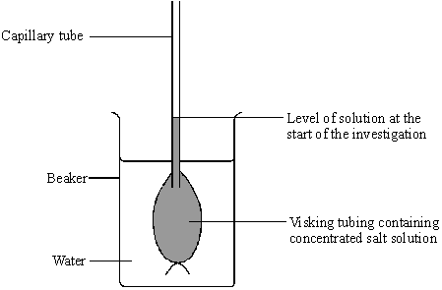

(a) What is osmosis?

___________________________________________________________________

___________________________________________________________________

___________________________________________________________________

(3)

(b) (i) What will happen to the water level in the capillary tube during the investigation because of osmosis?

______________________________________________________________

(1)

(ii) Use your knowledge of osmosis to explain why this happens.

______________________________________________________________

(2)

Required Practical 3: Enzymes

Investigate the effect of pH on the rate of reaction of amylase enzyme.

- Catalase is an enzyme.

Catalase controls the following reaction:

hydrogen peroxide water + oxygen

A student did an investigation on catalase activity.

This is the method used.

1. Put 1 cm³ hydrogen peroxide solution in a test tube.

2. Add 1 cm³ of catalase solution.

• Bubbles of oxygen are produced.

• Bubbles cause foam to rise up the tube.

3. Measure the maximum height of the foam.

The diagram below shows the experiment.

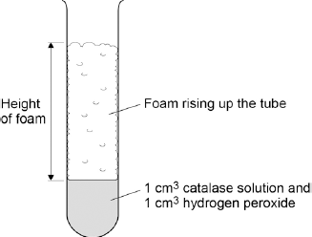

The experiment is carried out at 20 °C.

The table below shows some results from the investigation.

Temperature in °C | Maximum height of foam in cm
 | Test 1 | Test 2 | Test 3 | Mean
10 | 1.3 | 1.1 | 0.9 | 1.1
20 | 0.0 | 3.3 | 3.1 | 3.2
30 | 5.2 | 5.0 | 5.3 | 5.2
40 | 4.2 | 3.5 | 4.4 | 4.0
50 | 2.1 | 1.9 | 2.3 | 2.1
60 | 0.0 | 0.0 | 0.0 | 0.0

(a) Why did the student carry out the experiment three times at each temperature?

Tick one box.
To make the experiment more accurate
To prove the experiment was correct
To show the experiment was more repeatable

(1)

(b) The student thought one result was an anomaly.

Circle the anomaly in the table above.

(1)

(c) What did the student do with the anomalous result?

___________________________________________________________________

___________________________________________________________________

(1)

(d) Look at the table above.

What conclusion can be made as the temperature increases?

Tick one box.
Decreases the rate of reaction up to 30 °C
Decreases the rate of reaction up to 40 °C
Increases the rate of reaction up to 30 °C
Increases the rate of reaction up to 40 °C

(1)

(e) At which temperature was catalase denatured?

Tick one box.
10 °C
30 °C
40 °C
60 °C

(1)

(f) The student thought the optimum temperature for catalase activity was between 30 °C and 40 °C.

How could the investigation be improved to find a more precise value for the optimum temperature?

Tick one box.
Do the experiment at 70 °C and 80 °C
Do the experiment at 30 °C, 35 °C and 40 °C
Use less hydrogen peroxide solution
Use more catalase solution

(1)

(g) Amylase is the enzyme that controls the breakdown of starch to glucose.

Describe how the student could investigate the effect of pH on the breakdown of starch by amylase.

___________________________________________________________________

___________________________________________________________________

___________________________________________________________________

___________________________________________________________________

___________________________________________________________________

___________________________________________________________________

___________________________________________________________________

___________________________________________________________________

___________________________________________________________________

___________________________________________________________________

(4)

- The graph shows the effect of pH on the activities of three enzymes, X, Y and Z.
These enzymes help to digest food in the human digestive system.
Each enzyme is produced by a different part of the digestive system.

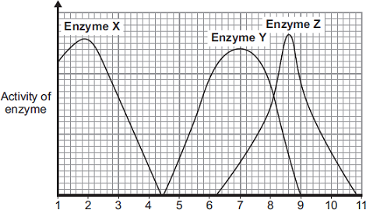

pH

(i) What is the optimum (best) pH for the action of enzyme Z?

__________________

(1)

(ii) The stomach makes a substance that gives the correct pH for enzyme action in the human stomach.

Name this substance. ____________________________________________

(1)

(iii) Which enzyme, X, Y or Z, will work best in the human stomach?

__________________

(1)

Required Practical 4: Food Tests

Use qualitative reagents to test for a range of carbohydrates, lipids and proteins.

- A nutritional drink was said to contain simple sugars and protein.

Describe how you could find out if these food substances were present in the drink.

___________________________________________________________________

___________________________________________________________________

___________________________________________________________________

___________________________________________________________________

___________________________________________________________________

___________________________________________________________________

___________________________________________________________________

___________________________________________________________________

(6)
- Complete the table below using your knowledge of food tests.

Test | Solution | Result if present

Starch

Sugar

Lipid

Protein

(8)

Required Practical 5: Photosynthesis

Investigate the effect of light intensity on the rate of photosynthesis using an aquatic organism such as

pondweed.

- In this question you will be assessed on using good English, organising information clearly and using specialist terms where appropriate.

Light intensity, carbon dioxide concentration and temperature are three factors that affect the rate of photosynthesis.

How would you investigate the effect of light intensity on the rate of photosynthesis?

The image below shows some of the apparatus you might use.

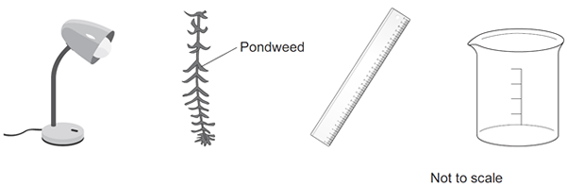

You should include details of:

• how you would set up the apparatus and the materials you would use

• the measurements you would make

• how you could make this a fair test.

_______________________________________________________________________

_______________________________________________________________________

_______________________________________________________________________

_______________________________________________________________________

_______________________________________________________________________

_______________________________________________________________________

_______________________________________________________________________

_______________________________________________________________________

_______________________________________________________________________

_______________________________________________________________________

_______________________________________________________________________

_______________________________________________________________________

_______________________________________________________________________

_______________________________________________________________________

(6)

The diagram shows bushes in a hedge growing near to a house.

The bushes were the same species and the same age.

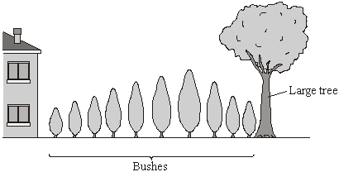

(a) (i) The student said, “I have noticed that the short bushes grow next to the house. I think that the more light the bushes get, the faster they will grow.”

Draw lines to match each of the student’s statements to the correct term.

Draw only two lines.

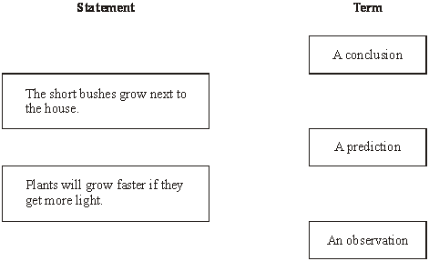

(2)

(ii) Complete the word equation for photosynthesis.

________________ + water (+ light energy) → _______________ + oxygen

(2)

(b) The student decided to investigate the effect of light intensity on the rate of photosynthesis.

She used the apparatus shown in the diagram.

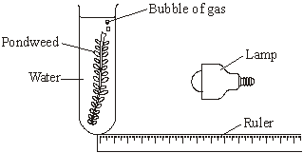

She measured the rate of photosynthesis by counting the number of gas bubbles given off each minute.

(i) Suggest how the student varied the intensity of the light received by the pondweed.

______________________________________________________________

______________________________________________________________

(1)

(ii) The student’s results are shown on the graph.

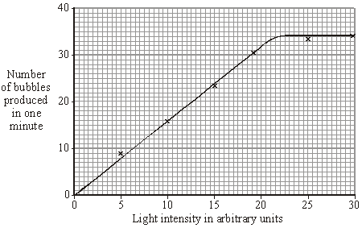

Describe the pattern shown on the graph.

______________________________________________________________

______________________________________________________________

______________________________________________________________

(2)

(iii) This is what the student wrote for her conclusion.

“Increasing the light intensity increases the rate of photosynthesis of the pondweed.”

Why was her conclusion incomplete?

______________________________________________________________

______________________________________________________________

(1)

Required Practical 6: Reaction Time

Plan and carry out an investigation into the effect of a factor on human reaction time.

- Two students investigated reflex action times.

This is the method used.

1. Student A sits with his elbow resting on the edge of a table.

2. Student B holds a ruler with the bottom of the ruler level with the thumb of Student A.

3. Student B drops the ruler.

4. Student A catches the ruler and records the distance.

5. Steps 1 to 4 are then repeated.

The same method was also used with Student A dropping the ruler and Student B catching the ruler.

(a) Give two variables the students controlled in their investigation.

1. _________________________________________________________________

2. _________________________________________________________________

(2)

(b) Figure 1 shows one of the results for the Student A.

Figure 1

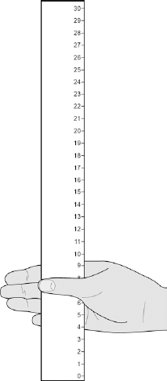

What is the reading shown in Figure 1?

___________________________________________________________________

Reading on ruler = ___________________________ cm

(1)

(c) Table 1 shows the students’ results.

Table 1

Test  number | Distance ruler dropped in cm
 | Student A | Student B
1 | 9 | 12
2 | 2 | 13
3 | 6 | 13
4 | 7 | 9
5 | 7 | 8
Mean | 7 | X

Circle the anomalous result in Table 1 for Student A.

(1)

(d) What is the median result for Student B?

Tick one box.
8
11
12
13

(1)

(e) Calculate the value of X in Table 1.

___________________________________________________________________

Mean distance ruler dropped = __________________ cm

(1)

(f) Figure 2 shows the scale used to convert distance of the ruler drop to reaction time.

Figure 2

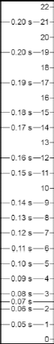

Calculate how much faster the reaction time of Student A was compared to Student B.

Use Figure 2 and Table 1.

___________________________________________________________________

Answer = _____________ s

(2)

(g) What improvement could the students make to the method so the results are more valid?

Tick one box.
Use alternate hands when catching the ruler
Carry out more repeats
Use a longer ruler for catching
Use more than two students to collect results

(1)

(h) Student A carried out a second investigation to see the effect of caffeine on the reflex action.

Table 2 shows his results.

Table 2

Test  number | Distance ruler dropped in cm
 | Without caffeine | With caffeine
1 | 9 | 5
2 | 6 | 5
3 | 9 | 4
4 | 6 | 7
5 | 10 | 4
Mean | 8 | 5

Give one conclusion about the effect of caffeine on reflex actions.

___________________________________________________________________

___________________________________________________________________

(1)

- Car drivers need quick reactions to avoid accidents.

A student uses a computer program to measure reaction time.

The computer screen shows a traffic light on red. The traffic light then changes to green.

The diagram below shows the change the person sees on the computer screen.

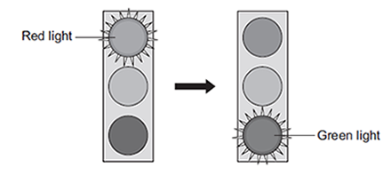

When the traffic light changes to green the person has to click the computer mouse as quickly as possible.

The computer program works out the time taken to react to the light changing colour.

(a) Special cells detect the change in colour.

(i) What word is used to describe special cells that detect a change in the environment?

Draw a ring around the correct answer.

(1)

(ii) Where in the body are the special cells that detect the change in colour of the traffic lights?

______________________________________________________________

(1)

(b) The student used the computer program on one computer to measure the reaction times of people of different ages.

(i) Give one variable the student should control so that a fair comparison can be made between the people of different ages.

______________________________________________________________

______________________________________________________________

(1)

(ii) The student did each measurement three times to calculate a mean value.

The table shows the results.

Age in years | Mean reaction time in milliseconds
15 | 242
30
45 | 221
60 | 258
75 | 364
90 | 526

The reaction times for the 30-year-old person were 192, 174 and 180 milliseconds.

Calculate the mean reaction time of the 30-year-old person.

______________________________________________________________

______________________________________________________________

Mean reaction time = ___________________ milliseconds

(1)

(iii) Which one of the following is an advantage of repeating each test three times and not doing the test just once?

Tick (✔) one box.
Any anomalies can be identified.
The results will be more precise.
There will be no errors.

(1)

(iv) Some people think that old people should not be allowed to drive a car.

Why is it more dangerous for old people to drive cars?

Use information from the table above to support your answer.

______________________________________________________________

______________________________________________________________

______________________________________________________________

______________________________________________________________

(2)

Required Practical 7: Field Investigations

Measure the population size of a common species in a habitat.

Use sampling techniques to investigate the effect of a factor on the distribution of this species.

- Some students wanted to find the number of thistle plants growing on a lawn.
The students placed 10 quadrats at different positions on the lawn.
Each quadrat measured 1 metre × 1 metre.
The students counted the number of thistle plants in each quadrat.

(a) Which method should the students use to decide where to place the 10 quadrats?

Tick () one box.

Place the quadrats as evenly as possible around the lawn.
Place 5 quadrats in areas with many thistle plants and 5 quadrats in areas with only a few thistle plants.
Place all the quadrats randomly on the lawn.

(1)

(b) The diagram shows the lawn with the positions of the thistle plants and the students’ 10 quadrats.

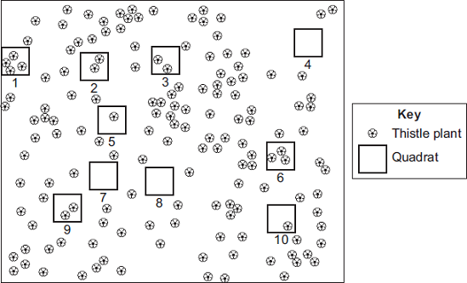

(i) Complete the table to show:

• how many thistle plants the students found in each of the first four quadrats

• the total number of thistle plants found in all 10 quadrats.

 | Quadrat  number | Number of thistle  plants in each  quadrat
 | 1
 | 2
 | 3
 | 4
 | 5 | 1
 | 6 | 3
 | 7 | 0
 | 8 | 0
 | 9 | 2
 | 10 | 1
 | Total

(2)

(ii) Calculate the mean number of thistle plants in one quadrat.

______________________________________________________________

Mean = ______________________________________________

(1)

(iii) The lawn measured 12 metres long and 10 metres wide.

Use your answer from part (b)(ii) to estimate the number of thistle plants on the lawn.

______________________________________________________________

______________________________________________________________

Estimated number of thistle plants = _______________________

(2)

(c) How could the students make their estimate more accurate?

___________________________________________________________________

___________________________________________________________________

(1)

- Ragwort is a plant that often grows as a weed in grassland.

The image below shows a ragwort plant.

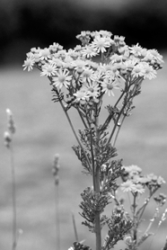

© Difydave/iStock

Some students estimated the number of ragwort plants growing in a field on a farm.

The students:

• placed a quadrat at 10 random positions in the field

• counted the number of ragwort plants in each quadrat.

The quadrat measured 1 metre × 1 metre. The area of the field was 80 000 m².

The table below shows the students’ results.

Quadrat number | Number of ragwort plants
1 | 1
2 | 0
3 | 3
4 | 0
5 | 0
6 | 0
7 | 5
8 | 0
9 | 0
10 | 2

(a) Complete the following calculation to estimate the number of ragwort plants in the field.

Use information from the table above.

Total number of ragwort plants in 10 quadrats = _____________________

Mean number of ragwort plants in 1 m² = __________________________

Therefore estimated number of ragwort plants in field = _______________

(2)

(b) What could the students do to get a more accurate estimate?

Tick (✔) one box.
Place the quadrat in 100 random positions.
Place the quadrat only in areas where they could see ragwort plants.
Place the quadrat in positions at the edge of the field.

(1)

(c) The farmer who owned the field kept horses.

If horses eat ragwort, the ragwort can poison them.

The farmer considered two methods of controlling ragwort in his field.

Method 1: Spraying with a selective weed killer

Method 2: Pulling out the ragwort plants by hand

In Method 1:

• the cost of the weed killer was £420

• the weed killer would not harm the grass but would kill all other plants

• the farmer could apply the weed killer from a sprayer towed by a tractor.

Method 2 could be done by local volunteers.

What are the advantages and disadvantages of using Method 2 instead of Method 1 for controlling ragwort?

Advantages of Method 2 ______________________________________________

___________________________________________________________________

___________________________________________________________________

___________________________________________________________________

Disadvantages of Method 2 ____________________________________________

___________________________________________________________________

___________________________________________________________________

___________________________________________________________________

(3)

