GCSE Biology
Required Practical Question Book

Name: | Class: | Teacher:

Practical 1  Microscopy | / 16 | Practical 6  Reaction Time | / 17
Practical 2  Osmosis | / 19 | Practical 7  Field Investigations | / 22
Practical 3  Enzymes | / 13 | Practical 8  Plant Responses | / 10
Practical 4  Food Tests | / 14 | Practical 9  Decay | / 15
Practical 5  Photosynthesis | / 13 | Practical 10  Microbiology | / 15
Required Practical 1: Microscopy
Use a light microscope to observe, draw and label a selection of plant and animal cells.
- The image below shows some muscle cells from the wall of the stomach, as seen through a light microscope.

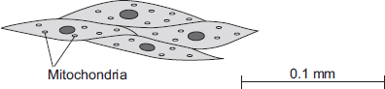

(a) Describe the function of muscle cells in the wall of the stomach.

___________________________________________________________________

___________________________________________________________________

(2)

(b) Figure above is highly magnified. The scale bar in Figure above represents 0.1 mm.

Use a ruler to measure the length of the scale bar and then calculate the magnification of Figure above.

___________________________________________________________________

___________________________________________________________________

Magnification = _______________ times

(2)

(c) The muscle cells in Figure above contain many mitochondria.

What is the function of mitochondria?

___________________________________________________________________

___________________________________________________________________

(2)

(d) The muscle cells also contain many ribosomes. The ribosomes cannot be seen in Figure above.

(i) What is the function of a ribosome?

______________________________________________________________

______________________________________________________________

(1)

(ii) Suggest why the ribosomes cannot be seen through a light microscope.

______________________________________________________________

______________________________________________________________

(1)

- The image below shows part of the surface of a leaf.

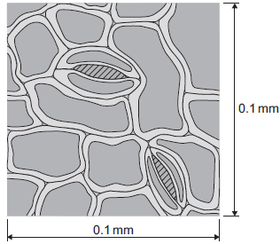

The length and width of this piece of leaf surface are both 0.1 mm.

(a) Calculate the number of stomata per mm² of this leaf surface.

______________________________________________________________

______________________________________________________________

_______________________ per mm²

(2)
- (a) The cheek cell in Figure 2 is magnified 250 times.

The width of the cell is shown by the line D to E.

Figure 2

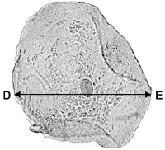

Calculate the width of the cheek cell in micrometres (µm).

Complete the following steps.

Measure the width of the cell using a ruler _____________________ mm

Use the equation to work out the real width of the cell in mm:

real size = 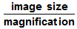 _____________________ mm

Convert mm to µm _____________________ µm

(3)

(b) A red blood cell is 8 µm in diameter.

A bacterial cell is 40 times smaller.

Calculate the diameter of the bacterial cell.

Tick one box.
0.02 µm
0.2 µm
2.0 µm
20.0 µm

(1)
- The photograph shows a red blood cell.

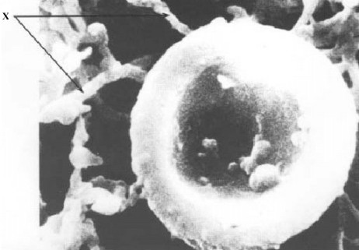

(a) The average diameter of a real red blood cell is 0.008 millimetres.
On the photograph, the diameter of the red blood cell is 100 millimetres.

Use the formula to calculate the magnification of the photograph.

Diameter on photograph = Real diameter × Magnification

___________________________________________________________________

___________________________________________________________________

Magnification = _______________________________

(2)

Required Practical 2: Osmosis
Investigate the effect of a range of concentrations of salt/sugar solutions on the mass of plant tissue.

- A student investigated the effect of different sugar solutions on potato tissue.

This is the method used.

1. Add 30 cm³ of 0.8 mol dm⁻³ sugar solution to a boiling tube.

2. Repeat step 1 with equal volumes of 0.6, 0.4 and 0.2 mol dm⁻³ sugar solutions.

3. Use water to give a concentration of 0.0 mol dm⁻³.

4. Cut five cylinders of potato of equal size using a cork borer.

5. Weigh each potato cylinder and place one in each tube.

6. Remove the potato cylinders from the solutions after 24 hours.

7. Dry each potato cylinder with a paper towel.

8. Reweigh the potato cylinders.

The table below shows the results.

Concentration of sugar solution in mol dm⁻³ | Starting  mass in g | Final mass  in g | Change of  mass in g | Percentage  (%) change
0.0 | 1.30 | 1.51 | 0.21 | 16.2
0.2 | 1.35 | 1.50 | 0.15 | X
0.4 | 1.30 | 1.35 | 0.05 | 3.8
0.6 | 1.34 | 1.28 | −0.06 | −4.5
0.8 | 1.22 | 1.11 | −0.11 | −9.0

(a) Calculate the value of X in the table above.

___________________________________________________________________

___________________________________________________________________

Percentage change in mass = _____________________ %

(2)

(b) Why did the student calculate the percentage change in mass as well as the change in grams?

___________________________________________________________________

___________________________________________________________________

(1)

(c) Complete the graph using data from the table above.

• Choose a suitable scale and label for the x-axis.

• Plot the percentage (%) change in mass.

• Draw a line of best fit.

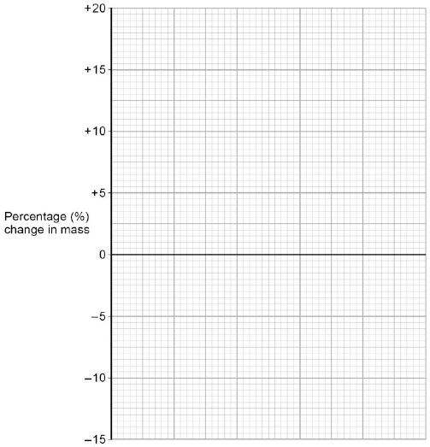

(4)

(d) Use your graph to estimate the concentration of the solution inside the potato cells.

Concentration = ________________________ mol dm⁻³

(1)

(e) The results in the table above show the percentage change in mass of the potato cylinders.

Explain why the percentage change results are positive and negative.

___________________________________________________________________

___________________________________________________________________

___________________________________________________________________

___________________________________________________________________

___________________________________________________________________

(3)

(f) Suggest two possible sources of error in the method given above.

1. _________________________________________________________________

___________________________________________________________________

2. _________________________________________________________________

___________________________________________________________________

(2)
- Some students set up this experiment to investigate osmosis. They filled two pieces of visking tubing with different liquids and left them both in a beaker of 5% sucrose solution for an hour.

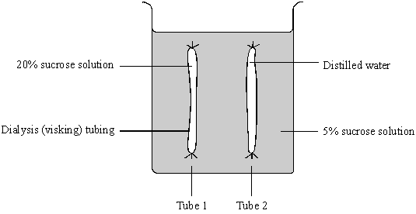

(a) Describe and explain the likely results after one hour.

___________________________________________________________________

___________________________________________________________________

___________________________________________________________________

___________________________________________________________________

___________________________________________________________________

___________________________________________________________________

(6)
Required Practical 3: Enzymes

Investigate the effect of pH on the rate of reaction of amylase enzyme.

- Fresh milk is a mixture of compounds including fat, protein and about 5 % lactose sugar. Lactose must be digested by the enzyme lactase, before the products can be absorbed.

Lactase can be added to fresh milk to pre-digest the lactose. This makes ‘lactose-free’ milk, which is suitable for people who do not produce enough lactase of their own.

A student investigated the effect of changing pH and temperature on the digestion of lactose in milk.

The results are shown in Tables 1 and 2.

Table 1  Effect of pH |  |  | Table 2  Effect of temperature
pH | Time taken to  digest lactose in  minutes |  | Temperature  in°C | Time taken to  digest lactose  in minutes
4.0 | 20 |  | 30 | 20
5.0 | 18 |  | 35 | 14
6.0 | 13 |  | 40 | 11
7.0 | 7 |  | 45 | 6
8.0 | 5 |  | 50 | 12
9.0 | 6 |  | 55 | 23

(a) The label on a carton of lactose-free milk states: ‘Lactase is normally produced in the stomach of mammals.’ The results in Table 1 show that this statement is unlikely to be true.

Explain how.

___________________________________________________________________

___________________________________________________________________

___________________________________________________________________

___________________________________________________________________

(2)

(b) Explain as fully as you can the results shown in Table 2.

___________________________________________________________________

___________________________________________________________________

___________________________________________________________________

___________________________________________________________________

___________________________________________________________________

(3)
- Some students investigated the effect of pH on the digestion of boiled egg white by an enzyme called pepsin. Egg white contains protein.

The students:

• put a glass tube containing boiled egg white into a test tube

• added a solution containing pepsin at pH 7

• set up six more tubes with solutions of pepsin at different pH values

• left the test tubes for 24 hours at room temperature.

The image below shows one of the test tubes, at the start and at the end of the 24 hours.

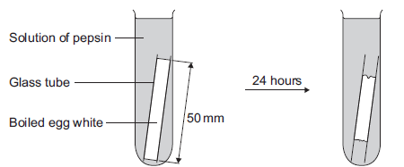

At start 24 hours later

(a) (i) Name the product of protein digestion.

______________________________________________________________

(1)

(ii) What type of enzyme digests protein?

Tick () one box.
amylase
lipase
protease

(1)

(b) The egg white in each tube was 50 mm long at the start of the investigation.
The table below shows the students’ results.

pH | Length in mm of boiled  egg white after 24 hours
1 | 38
2 | 20
3 | 34
4 | 45
5 | 50
6 | 50
7 | 50

(i) At which pH did the pepsin work best?

pH _________________

(1)

(ii) The answer you gave in part (b)(i) may not be the exact pH at which pepsin works best.

What could the students do to find a more accurate value for this pH?

______________________________________________________________

______________________________________________________________

______________________________________________________________

(2)

(iii) There was no change in the length of the egg white from pH 5 to pH 7.

Explain why.

______________________________________________________________

______________________________________________________________

______________________________________________________________

(2)

(c) Pepsin is made by the stomach.

Name the acid made by the stomach which allows pepsin to work well.

___________________________________________________________________

(1)

Required Practical 4: Food Tests

Use qualitative reagents to test for a range of carbohydrates, lipids and proteins.

- A nutritional drink was said to contain simple sugars and protein.

Describe how you could find out if these food substances were present in the drink.

___________________________________________________________________

___________________________________________________________________

___________________________________________________________________

___________________________________________________________________

___________________________________________________________________

___________________________________________________________________

___________________________________________________________________

___________________________________________________________________

(6)
- Complete the table below using your knowledge of food tests.

Test | Solution | Result if present

Starch

Sugar

Lipid

Protein

(8)

Required Practical 5: Photosynthesis

Investigate the effect of light intensity on the rate of photosynthesis using an aquatic organism such as

pondweed.

- In this question you will be assessed on using good English, organising information clearly and using specialist terms where appropriate.

Light intensity, carbon dioxide concentration and temperature are three factors that affect the rate of photosynthesis.

How would you investigate the effect of light intensity on the rate of photosynthesis?

The image below shows some of the apparatus you might use.

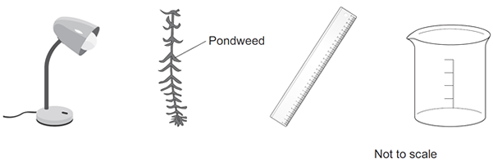

You should include details of:

• how you would set up the apparatus and the materials you would use

• the measurements you would make

• how you could make this a fair test.

_______________________________________________________________________

_______________________________________________________________________

_______________________________________________________________________

_______________________________________________________________________

_______________________________________________________________________

_______________________________________________________________________

_______________________________________________________________________

_______________________________________________________________________

_______________________________________________________________________

_______________________________________________________________________

_______________________________________________________________________

_______________________________________________________________________

_______________________________________________________________________

_______________________________________________________________________

_______________________________________________________________________

_______________________________________________________________________

_______________________________________________________________________

_______________________________________________________________________

(6)
- A student investigated the effect of temperature on the rate of photosynthesis in pondweed.

The diagram shows the way the experiment was set up.

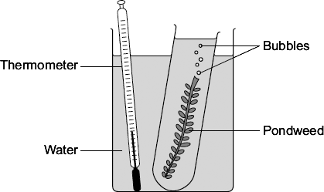

(a) The student needed to control some variables to make the investigation fair.

State two of these variables.

1. ____________________________________________________________

2. ____________________________________________________________

(2)

(b) The bubbles of gas are produced only while photosynthesis is taking place.

What two measurements would the student make to calculate the rate of photosynthesis?

1. ____________________________________________________________

2. ____________________________________________________________

(2)

(c) The graph shows the effect of temperature on the rate of photosynthesis.

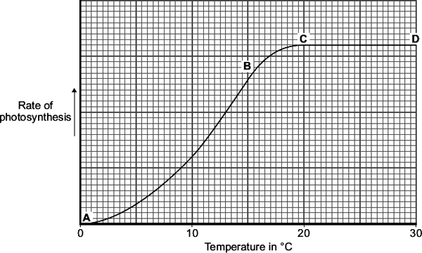

(i) Name the factor that limits the rate of photosynthesis between the points labelled A and B on the graph.

______________________________________________________________

(1)

(ii) Suggest which factor, carbon dioxide, oxygen or water, might limit the rate of photosynthesis between the points labelled C and D on the graph.

______________________________________________________________

(1)
- The table shows the students’ results.

 | Distance in cm | Number of bubbles  per minute
 | 10 | 84
 | 15 | 84
 | 20 | 76
 | 40 | 52
 | 50 | 26

(a) At distances between 15 cm and 50 cm, light was a limiting factor for photosynthesis. What evidence is there for this in the table?

______________________________________________________________

______________________________________________________________

(1)
Required Practical 6: Reaction Time

Plan and carry out an investigation into the effect of a factor on human reaction time.

- Two students investigated reflex action times.

This is the method used.

1. Student A sits with her elbow resting on the edge of a table.

2. Student B holds a ruler with the bottom of the ruler level with the thumb of Student A.

3. Student B drops the ruler.

4. Student A catches the ruler and records the distance, as shown in the diagram below.

5. Steps 1 to 4 were then repeated.

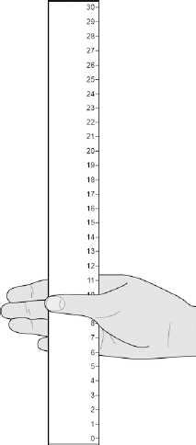

(a) Suggest two ways the students could improve the method to make sure the test would give valid results.

1. _________________________________________________________________

___________________________________________________________________

2. _________________________________________________________________

___________________________________________________________________

(2)

(b) The table below shows Student A’s results.

Test Number | Distance ruler dropped in mm
1 | 117
2 | 120
3 | 115
4 | 106
5 | 123
6 | 125
7 | 106

What is the median result?

Tick one box.
106
115
116
117
123

(1)

(c) The mean distance the ruler was dropped is 116 mm.

Calculate the mean reaction time.

Use the equation:

reaction time in s = 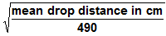

Give your answer to 3 significant figures

___________________________________________________________________

___________________________________________________________________

___________________________________________________________________

Mean reaction time = ______________________ s

(3)

(d) The students then measured Student A’s reaction time using a computer program.

This is the method used.

1. The computer shows a red box at the start.

2. As soon as the box turns green the student has to press a key on the keyboard as fast as possible.

3. The test is repeated five times and a mean reaction time is displayed.

Student A’s mean reaction time was 110 ms.

Using a computer program to measure reaction times is likely to be more valid than the method using a dropped ruler.

Give two reasons why.

1. _________________________________________________________________

___________________________________________________________________

2. _________________________________________________________________

___________________________________________________________________

(2)

(e) A woman has a head injury.

Her symptoms include:

• finding it difficult to name familiar objects

• not being able to remember recent events.

Suggest which part of her brain has been damaged.

___________________________________________________________________

(1)

(f) A man has a head injury.

He staggers and sways as he walks.

Suggest which part of his brain has been damaged.

___________________________________________________________________

(1)

- Car drivers need quick reactions to avoid accidents.

A student uses a computer program to measure reaction time.

The computer screen shows a traffic light on red. The traffic light then changes to green.

The diagram below shows the change the person sees on the computer screen.

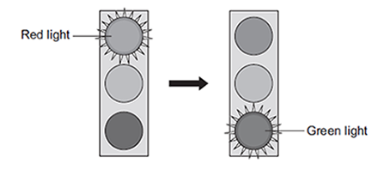

When the traffic light changes to green the person has to click the computer mouse as quickly as possible.

The computer program works out the time taken to react to the light changing colour.

(a) Special cells detect the change in colour.

(i) What word is used to describe special cells that detect a change in the environment?

Draw a ring around the correct answer.

(1)

(ii) Where in the body are the special cells that detect the change in colour of the traffic lights?

______________________________________________________________

(1)

(b) The student used the computer program on one computer to measure the reaction times of people of different ages.

(i) Give one variable the student should control so that a fair comparison can be made between the people of different ages.

______________________________________________________________

______________________________________________________________

(1)

(ii) The student did each measurement three times to calculate a mean value.

The table shows the results.

Age in years | Mean reaction time in milliseconds
15 | 242
30
45 | 221
60 | 258
75 | 364
90 | 526

The reaction times for the 30-year-old person were 192, 174 and 180 milliseconds.

Calculate the mean reaction time of the 30-year-old person.

______________________________________________________________

______________________________________________________________

Mean reaction time = ___________________ milliseconds

(1)

(iii) Which one of the following is an advantage of repeating each test three times and not doing the test just once?

Tick (✔) one box.
Any anomalies can be identified.
The results will be more precise.
There will be no errors.

(1)

(iv) Some people think that old people should not be allowed to drive a car.

Why is it more dangerous for old people to drive cars?

Use information from the table above to support your answer.

______________________________________________________________

______________________________________________________________

______________________________________________________________

______________________________________________________________

(2)

Required Practical 7: Field Investigations

Measure the population size of a common species in a habitat.

Use sampling techniques to investigate the effect of a factor on the distribution of this species.

- Some students wanted to find the number of thistle plants growing on a lawn.
The students placed 10 quadrats at different positions on the lawn.
Each quadrat measured 1 metre × 1 metre.
The students counted the number of thistle plants in each quadrat.

(a) Which method should the students use to decide where to place the 10 quadrats?

Tick () one box.

Place the quadrats as evenly as possible around the lawn.
Place 5 quadrats in areas with many thistle plants and 5 quadrats in areas with only a few thistle plants.
Place all the quadrats randomly on the lawn.

(1)

(b) The diagram shows the lawn with the positions of the thistle plants and the students’ 10 quadrats.

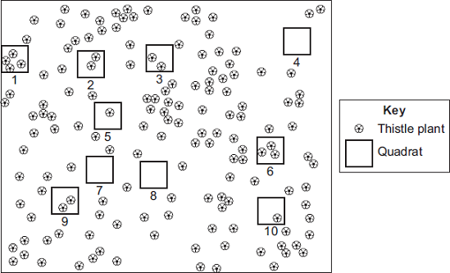

(i) Complete the table to show:

• how many thistle plants the students found in each of the first four quadrats

• the total number of thistle plants found in all 10 quadrats.

 | Quadrat  number | Number of thistle  plants in each  quadrat
 | 1
 | 2
 | 3
 | 4
 | 5 | 1
 | 6 | 3
 | 7 | 0
 | 8 | 0
 | 9 | 2
 | 10 | 1
 | Total

(2)

(ii) Calculate the mean number of thistle plants in one quadrat.

______________________________________________________________

Mean = ______________________________________________

(1)

(iii) The lawn measured 12 metres long and 10 metres wide.

Use your answer from part (b)(ii) to estimate the number of thistle plants on the lawn.

______________________________________________________________

______________________________________________________________

Estimated number of thistle plants = _______________________

(2)

(c) How could the students make their estimate more accurate?

___________________________________________________________________

___________________________________________________________________

(1)
- A grassy field on a farm measured 120 metres by 80 metres.

A student wanted to estimate the number of buttercup plants growing in the field.

The student found an area where buttercup plants were growing and placed a 1 m × 1 m quadrat in one position in that area.

Figure 1 shows the buttercup plants in the quadrat.

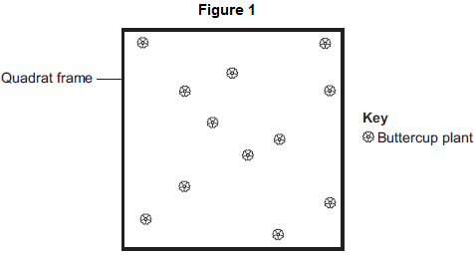

The student said, 'This result shows that there are 115 200 buttercup plants in the field.'

(a) (i) How did the student calculate that there were 115 200 buttercup plants in the field?

______________________________________________________________

______________________________________________________________

______________________________________________________________

______________________________________________________________

(2)

(ii) The student’s estimate of the number of buttercup plants in the field is probably not accurate. This is because the buttercup plants are not distributed evenly.

How would you improve the student’s method to give a more accurate estimate?

______________________________________________________________

______________________________________________________________

______________________________________________________________

______________________________________________________________

(2)

(b) Sunlight is one environmental factor that might affect the distribution of the buttercup plants.

(i) Give three other environmental factors that might affect the distribution of the buttercup plants.

1. ____________________________________________________________

2. ____________________________________________________________

3. ____________________________________________________________

(3)

- At the seashore, the tide comes in and goes out twice each day.

Some students investigated whether two different species of seaweed could live only at certain positions on a rocky shore.
Seaweeds are plant-like organisms that make their food by photosynthesis.

Figure 1 shows the two species of seaweed that the students investigated.

Figure 1

Bladder wrack Sea lettuce

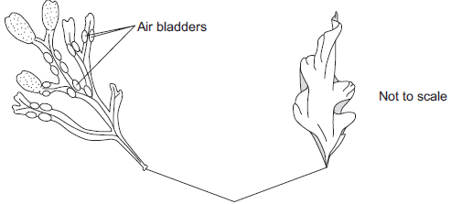
Holdfast
(fixes seaweed to the rock)

(a) The students:

1 placed a 50-metre tape measure on the rocks at right angles to the sea

2 placed a quadrat next to the tape measure

3 recorded whether each species was present or not.

The students repeated steps 2 and 3 every metre down the shore.

Figure 2 shows a section of the seashore and the students’ results.

Figure 2

Section of the seashore

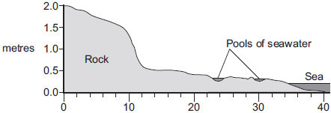
metres

Students’ results

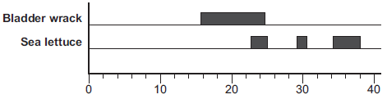
metres

(i) The students placed the quadrat at regular intervals along a transect line rather than placing the quadrat at random positions anywhere on the rocky shore.

Explain why.

______________________________________________________________

______________________________________________________________

______________________________________________________________

______________________________________________________________

(2)

(ii) How could the students have improved their investigation to ensure that they produced valid data?

______________________________________________________________

______________________________________________________________

______________________________________________________________

______________________________________________________________

(2)

(iii) Figure 2 is repeated here to help you answer this question.

Figure 2

Section of the seashore

metres

Students’ results

metres

The students concluded that bladder wrack is better adapted than sea lettuce to survive in dry conditions.

What is the evidence for this conclusion?

Use information from Figure 2.

______________________________________________________________

______________________________________________________________

______________________________________________________________

______________________________________________________________

(2)

(b) The bladder wrack has many air bladders.
The air bladders help the bladder wrack to float upwards when the sea covers it.

Suggest how this helps the bladder wrack to survive.

___________________________________________________________________

___________________________________________________________________

___________________________________________________________________

___________________________________________________________________

(2)

Required Practical 8: Plant Responses

Investigate the effect of light or gravity on the growth of newly germinated seedlings.

- A student grew a plant in an upright pot.

She then put the pot in a horizontal position and left the plant in the dark for two days.

Diagram 3 shows the potted plant after two days in the dark.

Explain fully why the plant responded in this way.

______________________________________________________________

______________________________________________________________

______________________________________________________________

______________________________________________________________

______________________________________________________________

______________________________________________________________

______________________________________________________________

______________________________________________________________

(4)

- Hormones called auxins control plant growth.

A student investigated plant growth responses in roots.

This is the method used.

1. Grow three bean seeds until their roots are 1 cm long.

2. Attach the three bean seeds to moist cotton wool in a Petri dish.

Each bean seed root should point in a different direction.

3. Fix the Petri dish vertically for 2 days in the dark.

Figure 1 shows the results.

Figure 1

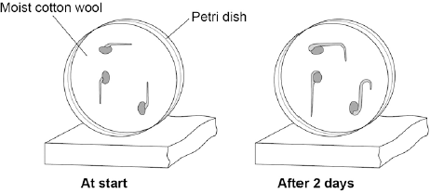

(a) Describe the direction of growth of the bean roots after 2 days.

Give one reason for this growth response.

Direction of root growth ________________________________________________

Reason ____________________________________________________________

___________________________________________________________________

(2)

(b) The student then noticed the shoots growing from the seeds.

He then:

1. put a light above the Petri dish but did not move the seeds

2. allowed the seeds to grow for 2 more days.

Predict the direction of growth of the bean shoots after 2 days.

Give one reason for your prediction.

Direction of root growth ________________________________________________

Reason ____________________________________________________________

(2)

(c) Ethene is a plant hormone.

Ethene causes fruit to ripen.

Scientists measured the concentration of ethene found in fruit at different stages of ripeness.

Figure 2 shows the results.

Figure 2

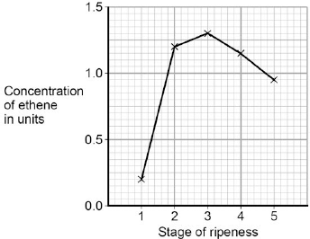

At which stage of ripeness is there most ethene?

Tick one box.
Stage 1
Stage 2
Stage 3
Stage 4
Stage 5

(1)

(d) Suggest how the scientists can find out if the result for Stage 1 was an anomaly.

___________________________________________________________________

___________________________________________________________________

(1)

Required Practical 9: Decay
Investigate the effect of temperature on the rate of decay of fresh milk by measuring pH change.

- Lipase is an enzyme that digests fat.

(a) (i) Complete the equation to show the digestion of fat.

Use the correct answer from the box.

glucose | glycerol | glycogen

fat fatty acids + ___________________

(1)

(ii) Name one organ that makes lipase.

______________________________________________________________

(1)

(b) Some students investigated the effect of bile on the digestion of fat by lipase.

The students:

1 mixed milk and bile in a beaker

2 put the pH sensor of a pH meter into the beaker

3 added lipase solution

4 recorded the pH at 2-minute intervals

5 repeated steps 1 to 4, but used water instead of bile.

Suggest two variables that the students should have controlled in this investigation.

1. _________________________________________________________________

___________________________________________________________________

2. _________________________________________________________________

___________________________________________________________________

(2)

(c) The graph shows the students’ results.

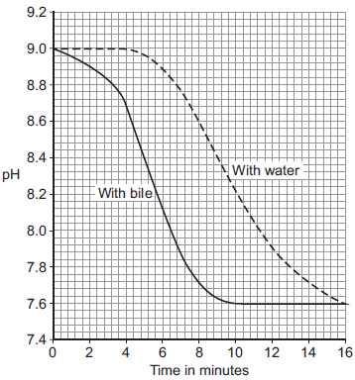

(i) Why did the pH decrease in both investigations?

______________________________________________________________

______________________________________________________________

(1)

(ii) Bile helps lipase to digest fat.

What evidence is there in the graph to support this conclusion?

______________________________________________________________

______________________________________________________________

(1)

(iii) Suggest one reason why the contents of both beakers had the same pH at the end of the investigations.

______________________________________________________________

______________________________________________________________

(1)

- A group of students investigated the effect of temperature on the action of the enzyme lipase.

The students:

• put 1 cm³ of lipase solution into a test tube

• put 5 cm³ of lipid into a different test tube

• put both tubes in a water bath at 5 °C for 3 minutes

• mixed the lipid with the lipase solution.

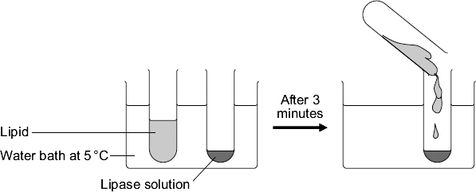

Every five minutes the students tested a sample of the mixture for lipid, until no lipid remained.
The students repeated the experiment at different temperatures.

(a) To make their investigation fair the students needed to control some variables.

Give one variable the students controlled in their investigation.

___________________________________________________________________

(1)

(b) The tubes of lipase solution and lipid were kept separately in the water bath for 3 minutes before mixing. Why?

Tick ( ) one box.

So that the lipase broke down the lipid quickly
So that the lipase and the lipid reached the right temperature
To give enough time for the lipase to break down the lipid
To give enough time for the water bath to heat up

(1)

The table shows the students’ results.

Temperature  in °C | Time taken until no lipid remained  in minutes
5 | 40
20 | 15
35 | 5
50 | 30
95 | lipid still there after 120 minutes

(c) Describe the effect on the breakdown of the lipid of increasing the temperature from 5 °C to 50 °C.

___________________________________________________________________

___________________________________________________________________

___________________________________________________________________

___________________________________________________________________

(2)

(d) Suggest two ways in which the students could have improved their investigation.

Use information from the students’ method and the results table to help you.

1. _________________________________________________________________

___________________________________________________________________

___________________________________________________________________

2. _________________________________________________________________

___________________________________________________________________

___________________________________________________________________

(2)

(e) (i) The lipase did not break down the lipid at 95 °C.

Why?

______________________________________________________________

______________________________________________________________

(1)

(ii) At 35 °C the lipase broke down the lipid after 5 minutes.

What new substances will be in the tube?

Draw a ring around one answer.

amino acids | fatty acids and glycerol | sugars

(1)

Required Practical 10: Microbiology

Investigate the effect of antiseptics or antibiotics on bacterial growth using agar plates and measuring

zones of inhibition.
- The diagram shows a method used to grow pure cultures of a bacterium.

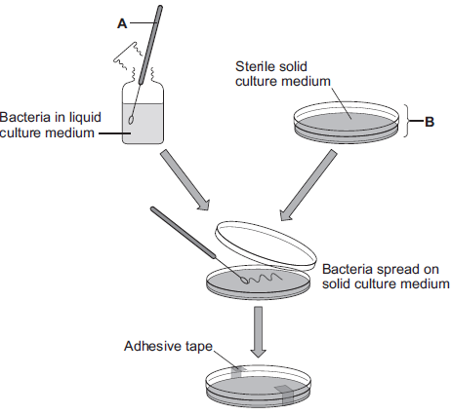

(a) Name apparatus A and apparatus B.

Apparatus A _______________________________

Apparatus B _______________________________

(2)

(b) (i) Why should apparatus A and apparatus B be sterilised before they are used?

______________________________________________________________

______________________________________________________________

(1)

(ii) How should apparatus A be sterilised?

Tick () one box.

Using enzymes
Using a flame
In an incubator

(1)

(iii) Adhesive tape is used to secure the lid on apparatus B.

Give one reason why the lid of apparatus B should be securely taped in place.

______________________________________________________________

______________________________________________________________

(1)

(c) What is the maximum temperature that should be used in schools to grow the bacteria in apparatus B?

Draw a ring around the correct answer.

10 °C | 25 °C | 50 °C

(1)
- A student is given a tube containing a liquid nutrient medium. The medium contains one type of bacterium.

(a) In this question you will be assessed on using good English, organising information clearly and using specialist terms where appropriate.

The student is told to grow some of the bacteria on agar jelly in a Petri dish.

Describe how the student should prepare an uncontaminated culture of the bacterium in the Petri dish.

You should explain the reasons for each of the steps you describe.

___________________________________________________________________

___________________________________________________________________

___________________________________________________________________

___________________________________________________________________

___________________________________________________________________

___________________________________________________________________

___________________________________________________________________

___________________________________________________________________

___________________________________________________________________

___________________________________________________________________

___________________________________________________________________

(6)

(b) After the culture had been prepared, the student added one drop of each of five disinfectants, A, B, C, D and E, onto the culture.

The diagram shows the appearance of the Petri dish 3 days later.

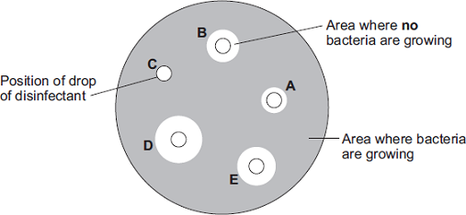

(i) There are areas on the agar jelly where no bacteria are growing.

Why?

______________________________________________________________

______________________________________________________________

(1)

(ii) The student concluded that disinfectant D would be the best for using around the home.

Give one reason why the student might be correct.

______________________________________________________________

______________________________________________________________

______________________________________________________________

Give one reason why the student might not be correct.

______________________________________________________________

______________________________________________________________

______________________________________________________________

(2)

