GCSE Chemistry Trilogy (F)
Required Practical Question Book

Name: | Class: | Teacher:

Practical 1  Making Salts | / 13 | Practical 4  Chromatography | / 13
Practical 2  Temperature Changes | / 15 | Practical 5  Water Purification | / 12
Practical 3  Rates of Reaction | / 19 | Practical 6  Electrolysis | / 16

Required Practical 1: Making Salts
Preparation of a pure, dry sample of a soluble salt from an insoluble oxide or carbonate, using a Bunsen
burner to heat dilute acid and a water bath or electric heater to evaporate the solution.

- A student investigated the reaction of copper carbonate with dilute sulfuric acid.

The student used the apparatus shown in the figure below.

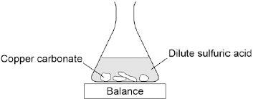

(a) Complete the state symbols in the equation.

CuCO₃ (___) + H₂SO₄ (aq) → CuSO₄ (aq) + H₂O (___) + CO₂ (g)

(2)

(b) Why did the balance reading decrease during the reaction?

Tick one box.
The copper carbonate broke down.
A salt was produced in the reaction.
A gas was lost from the flask.
Water was produced in the reaction.

(1)

(c) Describe a safe method for making pure crystals of copper sulfate from copper carbonate and dilute sulfuric acid. Use the information in the figure above to help you.

In your method you should name all of the apparatus you will use.

___________________________________________________________________

___________________________________________________________________

___________________________________________________________________

___________________________________________________________________

___________________________________________________________________

___________________________________________________________________

___________________________________________________________________

___________________________________________________________________

___________________________________________________________________

___________________________________________________________________

(6)

(d) The percentage atom economy for a reaction is calculated using:

The equation for the reaction of copper carbonate and sulfuric acid is:

CuCO₃ + H₂SO₄ → CuSO₄ + H₂O + CO₂

Relative formula masses : CuCO₃ = 123.5; H₂SO₄ = 98.0; CuSO₄ = 159.5

Calculate the percentage atom economy for making copper sulfate from copper carbonate.

___________________________________________________________________

___________________________________________________________________

___________________________________________________________________

___________________________________________________________________

___________________________________________________________________

Atom economy = __________________ %

(3)

(e) Give one reason why is it important for the percentage atom economy of a reaction to be as high as possible.

___________________________________________________________________

___________________________________________________________________

(1)

Required Practical 2: Temperature Changes
Investigate the variables that affect temperature changes in reacting solutions such as, e.g. acid plus metals, acid plus carbonates, neutralisations, displacement of metals.

- A student investigated the reactivity of different metals.

The student used the apparatus shown in the figure below.

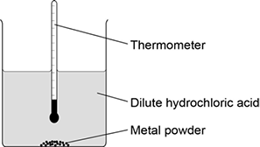

The student used four different metals.

The student measured the temperature rise for each metal three times.

The student’s results are shown in the table below.

Metal | Temperature rise in °C |  |  | Mean  temperature  rise in °C
 | Test 1 | Test 2 | Test 3
Calcium | 17.8 | 16.9 | 17.5
Iron | 6.2 | 6.0 | 6.1 | 6.1
Magnesium | 12.5 | 4.2 | 12.3 | 12.4
Zinc | 7.8 | 8.0 | 7.6 | 7.8

(a) Give two variables the student should control so that the investigation is a fair test.

1. _________________________________________________________________

___________________________________________________________________

2. _________________________________________________________________

___________________________________________________________________

(2)

(b) One of the results for magnesium is anomalous.

Which result is anomalous?

Suggest one reason why this anomalous result was obtained.

Result _____________________________________________________________

___________________________________________________________________

Reason ____________________________________________________________

___________________________________________________________________

(2)

(c) Calculate the mean temperature rise for calcium.

___________________________________________________________________

Mean temperature rise = _______________ °C

(1)

(d) The temperature rose when the metals were added to sulfuric acid.

Give one other observation that might be made when the metal was added to sulfuric acid.

How would this observation be different for the different metals?

___________________________________________________________________

___________________________________________________________________

___________________________________________________________________

___________________________________________________________________

(2)

(e) Aluminium is more reactive than iron and zinc but less reactive than calcium and magnesium.

Predict the temperature rise when aluminium is reacted with dilute hydrochloric acid.

___________________________________________________________________

Temperature rise = _______________ °C

(1)

- This question is about temperature changes.

(a) A student investigated the temperature change when 8 g of sodium nitrate dissolves in 50 cm³ of water.

The diagram below shows the apparatus the student used.

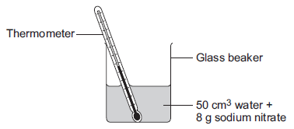

The student did the experiment five times.

Table 1 shows the results.

Table 1
Experiment | Decrease in temperature of water in °C
1 | 5.9
2 | 5.7
3 | 7.2
4 | 5.6
5 | 5.8

(i) Calculate the mean decrease in temperature.

Do not use the anomalous result in your calculation.

______________________________________________________________

______________________________________________________________

Mean decrease in temperature = ___________________ °C

(2)

(ii) Suggest one change in the apparatus in the diagram above which would improve the accuracy of the results.

Give a reason for your answer.

______________________________________________________________

______________________________________________________________

______________________________________________________________

______________________________________________________________

(2)

(b) The student investigated the temperature change when different masses of sodium carbonate were added to 50 cm³ of water at 20 °C.

Table 2 below shows the results.

Table 2
Mass of sodium carbonate in g | Final temperature of solution in °C
2.0 | 21.5
4.0 | 23.0
6.0 | 24.5
8.0 | 26.0
10.0 | 26.6
12.0 | 26.6
14.0 | 26.6

Describe the relationship between the mass of sodium carbonate added and the final temperature of the solution.

Use values from Table 2 in your answer.

___________________________________________________________________

___________________________________________________________________

___________________________________________________________________

___________________________________________________________________

___________________________________________________________________

___________________________________________________________________

(3)

Required Practical 3: Rates of Reaction
Investigate how changes in concentration affect the rates of reactions by both measuring the volume of a gas produced and monitoring a change in colour or turbidity.

- Lithium carbonate reacts with dilute hydrochloric acid.

A group of students investigated the volume of gas produced.

This is the method used.

1. Place a known mass of lithium carbonate in a conical flask.

2. Measure 10 cm³ of dilute hydrochloric acid using a measuring cylinder.

3. Pour the acid into the conical flask.

4. Place a bung in the flask and collect the gas as shown in Figure 1.

Figure 1

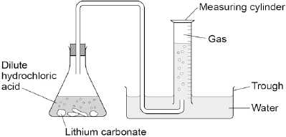

(a) Figure 2 shows the measuring cylinder.

Figure 2

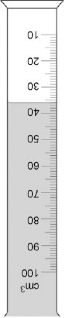

What volume of gas has been collected?

Volume = __________________ cm³

(1)

(b) The table below shows the students’ results.

Mass of lithium carbonate in g | Volume of gas in cm³
0.0 | 0
0.1 | 22
0.2 | 44
0.3 | 50
0.4 | 88
0.5 | 96
0.6 | 96
0.7 | 96

On Figure 3:

• Plot these results on the grid.

• Complete the graph by drawing two straight lines of best fit.

Figure 3

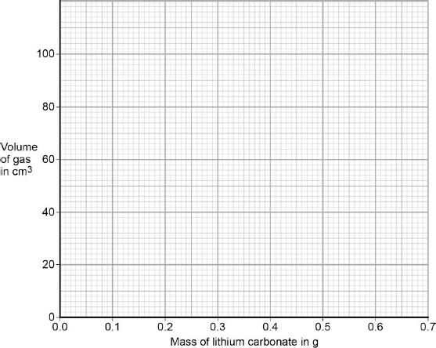

(4)

(c) What are two possible reasons for the anomalous result?

Tick two boxes.
Too much lithium carbonate was added.
The bung was not pushed in firmly enough.
There was too much water in the trough.
The measuring cylinder was not completely over the delivery
The conical flask was too small.

(2)

(d) Describe the pattern the graph shows up to 0.4 g of lithium carbonate added.

___________________________________________________________________

___________________________________________________________________

___________________________________________________________________

___________________________________________________________________

(2)

(e) Lithium carbonate decomposes when heated.

The equation shows the decomposition of lithium carbonate.

Li₂CO₃ (s) → Li₂O (s) + CO₂ (g)

Figure 4 shows the apparatus a student used to decompose lithium carbonate.

Figure 4

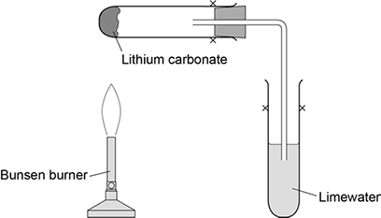

Why does the limewater bubble?

___________________________________________________________________

___________________________________________________________________

(1)

(f) The student repeated the experiment with potassium carbonate.

The limewater did not bubble.

Suggest why there were no bubbles in the limewater.

___________________________________________________________________

___________________________________________________________________

(1)

- A student investigated the effect of temperature on the rate of a reaction.

Figure 1 shows an experiment.

Figure 1

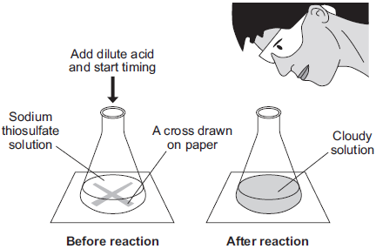

The student:

• put 50 cm³ sodium thiosulfate solution into a conical flask

• heated the sodium thiosulfate solution to the required temperature

• put the flask on a cross drawn on a piece of paper

• added 5 cm³ dilute hydrochloric acid and started a stopclock

• stopped the stopclock when the cross could no longer be seen

• repeated the experiment at different temperatures.

The equation for the reaction is:

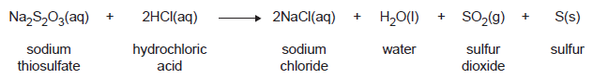

(a) Which product is a gas?

____________________________________

(1)

(b) Figure 2 shows the results of this experiment at five different temperatures.

The circled result point is anomalous.

Figure 2

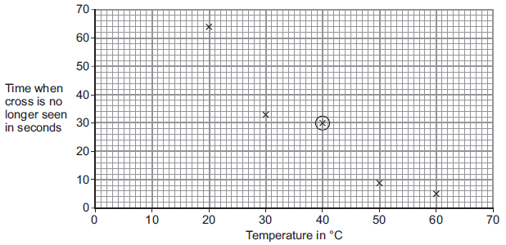

(i) Draw a line of best fit on Figure 2 to show how the reaction time varied with reaction temperature.

(1)

(ii) Give a possible reason for the anomalous result at 40 °C.

______________________________________________________________

______________________________________________________________

(1)

(iii) The reaction at 20 °C produced 0.32 g of sulfur in 64 seconds.

Calculate the rate of the reaction at 20 °C using the equation:

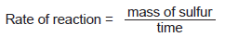

______________________________________________________________

______________________________________________________________

______________________________________________________________

______________________________________________________________

Rate of reaction = __________________ grams per second

(2)

(iv) Give two reasons why the rate of the reaction increases as the temperature increases.

Tick (✔) two boxes.
The particles move faster.
The particles collide less often.
All the particles have the same energy.
The particles collide with more energy.
The number of particles increases.

(2)

(v) Use the correct answer from the box to complete the sentence.

activation | collision | exothermic

The minimum amount of energy particles must have to react is called

the __________________________ energy.

(1)

Required Practical 4: Chromatography

Investigate how paper chromatography can be used to separate and tell the difference between coloured substances.
- A student investigated a food colouring using paper chromatography.

This is the method used.

1. Put a spot of food colouring X on the start line.

2. Put spots of three separate dyes, A, B and C, on the start line.

3. Place the bottom of the paper in water and leave it for several minutes.

(a) Figure 1 shows the apparatus the student used.

Figure 1

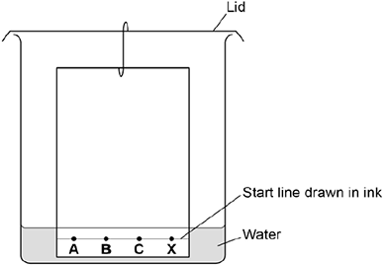

Give two mistakes the student made in setting up the experiment.

Tick two boxes.
The lid was on the beaker.
The paper did not touch the bottom of the beaker.
The spots were too small.
The start line was drawn in ink.
The water level was above the spots.

(2)

(b) Another student set the experiment up correctly.

Figure 2 shows the student’s results.

Figure 2

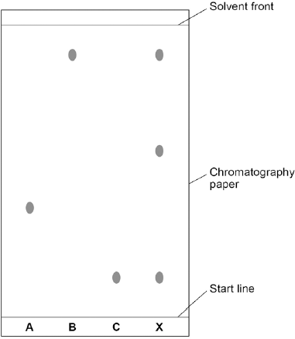

How many dyes were in X?

Tick one box.

1 |  |  | 3 |  |  | 4 |  |  | 6

(1)

(c) Which dye, A, B or C, is not in X?

Write your answer in the box.

(1)

(d) Use Figure 2 to complete the table below.

Calculate the value for R_{f} for dye A.

 | Distance in mm
Distance moved by dye A | ______________
Distance from start line to solvent front | ______________

Use the equation:

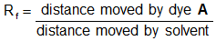

Give your answer to two significant figures.

___________________________________________________________________

___________________________________________________________________

___________________________________________________________________

R_{f} value = ________________________________

(5)

- Colours are used to coat some chocolate sweets.

Some of these colours are given E-numbers.

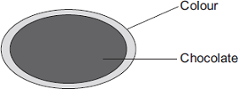

Use the correct word from the box to complete the sentence.

additive | element | fuel

An E-number is used to identify a permitted food ____________________________

(1)

(b) Chromatography was used to compare three of the colours used to coat the chocolate sweets.

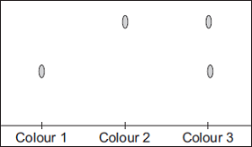

What do these results tell you about these three colours?

___________________________________________________________________

___________________________________________________________________

___________________________________________________________________

___________________________________________________________________

(3)

Required Practical 5: Water Purification
Analysis and purification of water samples from different sources. To include pH measurement, removal of dissolved solids and distillation.
- Some countries make drinking water from sea water.
- Complete the figure below to show how you can distil salt solution to produce and collect pure water.

Label the following:

• pure water

• salt solution

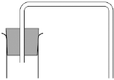

(3)

(b) How could the water be tested to show it is pure?

Give the expected result of the test for pure water.

___________________________________________________________________

___________________________________________________________________

___________________________________________________________________

___________________________________________________________________

___________________________________________________________________

(2)

(c) Why is producing drinking water from sea water expensive?

___________________________________________________________________

___________________________________________________________________

(1)

- Rock salt is a mixture of sand and salt.

Salt dissolves in water. Sand does not dissolve in water.

Some students separated rock salt. This is the method used.

1. Place the rock salt in a beaker.

2. Add 100 cm³ of cold water.

3. Allow the sand to settle to the bottom of the beaker.

4. Carefully pour the salty water into an evaporating dish.

5. Heat the contents of the evaporating dish with a Bunsen burner until salt crystals start to form.

(a) Suggest one improvement to step 2 to make sure all the salt is dissolved in the water.

___________________________________________________________________

___________________________________________________________________

(1)

(b) The salty water in step 4 still contained very small grains of sand.

Suggest one improvement to step 4 to remove all the sand.

___________________________________________________________________

(1)

(c) Suggest one safety precaution the students should take in step 5.

___________________________________________________________________

(1)

(d) Another student removed water from salty water using the apparatus in the figure below.

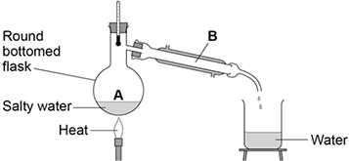

Describe how this technique works by referring to the processes at A and B.

___________________________________________________________________

___________________________________________________________________

___________________________________________________________________

(2)

(e) What is the reading on the thermometer during this process?

__________________ °C

(1)

Required Practical 6: Electrolysis

Investigate what happens when aqueous solutions are electrolysed using inert electrodes.

- Where copper ore has been mined there are areas of land that contain very low percentages of copper compounds.

One way to extract the copper is to grow plants on the land.

The plants absorb copper compounds through their roots.

The plants are burned to produce copper oxide.

The copper oxide produced from plants can be reacted to produce copper or copper sulfate solution, as shown in Figure 1.

Figure 1

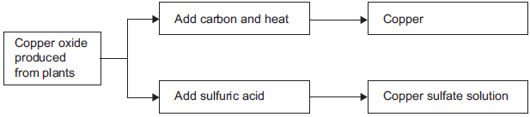

(a) Draw a ring around the correct answer to complete each sentence.

(i) | Copper ores contain enough copper to make extraction of the metal | carbon neutral.  economical.  reversible.

(1)

(ii) | Using plants to extract metals is called | photosynthesis.  phytomining.  polymerisation.

(1)

(iii) | Copper oxide reacts with carbon to produce copper and | carbon dioxide.  oxygen.  sulfur dioxide.

(1)

(b) Copper is produced from copper sulfate solution by displacement using iron or by electrolysis.

(i) Complete the word equation.

copper sulfate + iron ___________ + ___________

(2)

(ii) Figure 2 shows the electrolysis of copper sulfate solution.

Figure 2

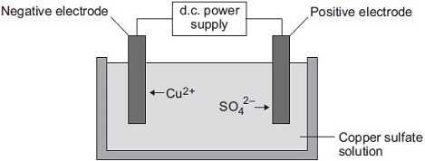

Why do copper ions go to the negative electrode?

______________________________________________________________

______________________________________________________________

(1)

(c) Suggest two reasons why copper should not be disposed of in landfill sites.

___________________________________________________________________

___________________________________________________________________

___________________________________________________________________

___________________________________________________________________

(2)

- An investigation into the electrolyte copper sulphate solution was carried out as shown.

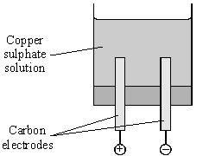

(a) What does electrolyte mean?

___________________________________________________________________

___________________________________________________________________

___________________________________________________________________

(2)

(b) These were the observations.

Negative electrode | solid formed
Positive electrode | gas given off

(i) Name the solid formed.

______________________________________________________________

(1)

(ii) Name the gas given off.

______________________________________________________________

(1)

(c) How could a sample of gas be collected at the positive electrode?

___________________________________________________________________

___________________________________________________________________

(2)

(d) Suggest why the blue colour of copper sulphate becomes paler during the investigation.

___________________________________________________________________

___________________________________________________________________

(2)

