GCSE Chemistry
Required Practical Question Book

Name: | Class: | Teacher:

Practical 1  Making Salts | / 29 | Practical 5  Water Purification | / 18
Practical 2  Temperature Changes | / 16 | Practical 6  Electrolysis | / 27
Practical 3  Rates of Reaction | / 25 | Practical 7  Neutralisation | / 22
Practical 4  Chromatography | / 16 | Practical 8  Identifying Ions | / 14

Required Practical 1: Making Salts
Preparation of a pure, dry sample of a soluble salt from an insoluble oxide or carbonate, using a Bunsen
burner to heat dilute acid and a water bath or electric heater to evaporate the solution.

- Calcium chloride (CaCl₂) is a soluble salt.

Calcium chloride can be made by reacting dilute hydrochloric acid with either solid calcium oxide or solid calcium carbonate.

(a) Name the type of reaction that takes place when dilute hydrochloric acid reacts with calcium oxide.

___________________________________________________________________

(1)

(b) Write a balanced symbol equation for the reaction of dilute hydrochloric acid with calcium oxide.

___________________________________________________________________

(2)

(c) A student added solid calcium oxide to dilute hydrochloric acid in a beaker.

The student added solid calcium carbonate to dilute hydrochloric acid in another beaker.

Describe one difference between the two reactions that the student would see.

___________________________________________________________________

___________________________________________________________________

(1)

(d) Describe how crystals of calcium chloride can be made from calcium carbonate and dilute hydrochloric acid.

___________________________________________________________________

___________________________________________________________________

___________________________________________________________________

___________________________________________________________________

___________________________________________________________________

___________________________________________________________________

___________________________________________________________________

___________________________________________________________________

(4)

(e) A student dissolved some crystals of a salt in water.

The student added sodium hydroxide solution to the salt solution.

The student added sodium hydroxide solution until it was in excess.

(i) Describe what the student would see if the salt contained calcium ions.

______________________________________________________________

______________________________________________________________

______________________________________________________________

(2)

(ii) Why does the result you have described in part (e)(i) not prove that the salt contains calcium ions?

______________________________________________________________

______________________________________________________________

(1)

(iii) Describe an additional test the student could do that would prove the salt contains calcium ions.

______________________________________________________________

______________________________________________________________

______________________________________________________________

(2)
- Describe a safe method for making pure crystals of copper sulfate from copper carbonate and dilute sulfuric acid. Use the information in the figure below to help you.

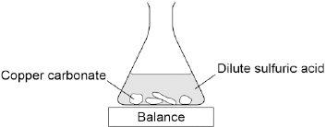

In your method you should name all of the apparatus you will use.

___________________________________________________________________

___________________________________________________________________

___________________________________________________________________

___________________________________________________________________

___________________________________________________________________

___________________________________________________________________

___________________________________________________________________

___________________________________________________________________

___________________________________________________________________

(6)
- A student investigated the reactions of copper carbonate and copper oxide with dilute hydrochloric acid.

In both reactions one of the products is copper chloride.

(a) Describe how a sample of copper chloride crystals could be made from copper carbonate and dilute hydrochloric acid.

___________________________________________________________________

___________________________________________________________________

___________________________________________________________________

___________________________________________________________________

___________________________________________________________________

___________________________________________________________________

___________________________________________________________________

___________________________________________________________________

(4)

(b) A student wanted to make 11.0 g of copper chloride.

The equation for the reaction is:

CuCO₃ + 2HCl → CuCl₂ + H₂O + CO₂

Relative atomic masses, A_{r}: H = 1; C = 12; O = 16; Cl = 35.5; Cu = 63.5

Calculate the mass of copper carbonate the student should react with dilute hydrochloric acid to make 11.0 g of copper chloride.

___________________________________________________________________

___________________________________________________________________

___________________________________________________________________

___________________________________________________________________

Mass of copper carbonate = _________________________ g

(4)

(c) The percentage yield of copper chloride was 79.1 %.

Calculate the mass of copper chloride the student actually produced.

___________________________________________________________________

___________________________________________________________________

Actual mass of copper chloride produced = ____________ g

(2)

Required Practical 2: Temperature Changes
Investigate the variables that affect temperature changes in reacting solutions such as, e.g. acid plus metals, acid plus carbonates, neutralisations, displacement of metals.

- This question is about temperature changes.

(a) A student investigated the temperature change when 8 g of sodium nitrate dissolves in 50 cm³ of water.

The diagram below shows the apparatus the student used.

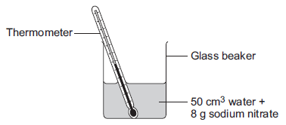

The student did the experiment five times.

Table 1 shows the results.

Table 1
Experiment | Decrease in temperature of water in °C
1 | 5.9
2 | 5.7
3 | 7.2
4 | 5.6
5 | 5.8

(i) Calculate the mean decrease in temperature.

Do not use the anomalous result in your calculation.

______________________________________________________________

______________________________________________________________

Mean decrease in temperature = ___________________ °C

(2)

(ii) Suggest one change in the apparatus in the diagram above which would improve the accuracy of the results.

Give a reason for your answer.

______________________________________________________________

______________________________________________________________

______________________________________________________________

______________________________________________________________

(2)

(b) The student investigated the temperature change when different masses of sodium carbonate were added to 50 cm³ of water at 20 °C.

Table 2 below shows the results.

Table 2
Mass of sodium carbonate in g | Final temperature of solution in °C
2.0 | 21.5
4.0 | 23.0
6.0 | 24.5
8.0 | 26.0
10.0 | 26.6
12.0 | 26.6
14.0 | 26.6

Describe the relationship between the mass of sodium carbonate added and the final temperature of the solution.

Use values from Table 2 in your answer.

___________________________________________________________________

___________________________________________________________________

___________________________________________________________________

___________________________________________________________________

___________________________________________________________________

___________________________________________________________________

(3)

- A student investigated the temperature change when zinc reacts with copper sulfate solution.

The student used a different concentration of copper sulfate solution for each experiment.

The student used the apparatus shown below.

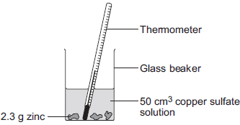

The student:

• measured 50 cm³ copper sulfate solution into a glass beaker

• measured the temperature of the copper sulfate solution

• added 2.3 g zinc

• measured the highest temperature

• repeated the experiment using copper sulfate solution with different concentrations.

The equation for the reaction is:

Zn(s) + CuSO₄(aq) Cu(s) + ZnSO₄(aq)

zinc + copper sulfate solution copper + zinc sulfate solution

(a) The thermometer reading changes during the reaction.

Give one other change the student could see during the reaction.

___________________________________________________________________

___________________________________________________________________

(1)

(b) Suggest one improvement the student could make to the apparatus.

Give a reason why this improves the investigation.

Improvement ________________________________________________________

___________________________________________________________________

Reason ____________________________________________________________

___________________________________________________________________

(2)

(c) In this question you will be assessed on using good English, organising information clearly and using specialist terms where appropriate.

The student’s results are shown in the table.

Table

Experiment number | Concentration of  copper sulfate  in moles per dm³ | Increase in temperature in °C
1 | 0.1 | 5
2 | 0.2 | 10
3 | 0.3 | 12
4 | 0.4 | 20
5 | 0.5 | 25
6 | 0.6 | 30
7 | 0.7 | 35
8 | 0.8 | 35
9 | 0.9 | 35
10 | 1.0 | 35

Describe and explain the trends shown in the student’s results.

___________________________________________________________________

___________________________________________________________________

___________________________________________________________________

___________________________________________________________________

___________________________________________________________________

___________________________________________________________________

___________________________________________________________________

___________________________________________________________________

___________________________________________________________________

___________________________________________________________________

(6)

Required Practical 3: Rates of Reaction
Investigate how changes in concentration affect the rates of reactions by both measuring the volume of a gas produced and monitoring a change in colour or turbidity.

- A student investigated the reaction between magnesium metal and dilute hydrochloric acid.

The student placed 25 cm³ of dilute hydrochloric acid in a conical flask and set up the apparatus as shown in the diagram.

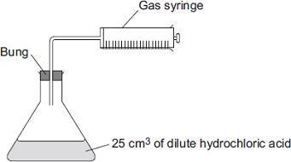

The student:

• took the bung out of the flask and added a single piece of magnesium ribbon 8 cm long

• put the bung back in the flask and started a stopwatch

• recorded the volume of gas collected after 1 minute

• repeated the experiment using different temperatures of acid.

The student plotted his results on a graph.

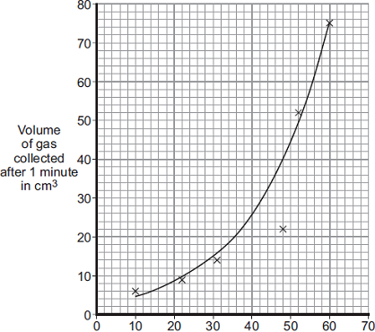
Temperature of acid in °C

(a) Write the correct state symbols in the equation.

Choose from (s) for solid, (l) for liquid, (g) for gas and (aq) for aqueous.

Mg (….) + 2 HCl (….) MgCl₂ (….) + H₂ (….)

(2)

(b) The diagram shows a gas syringe after 1 minute.

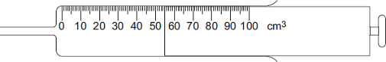

(i) What volume of gas has been collected in the gas syringe after 1 minute?

Volume = ____________ cm³

(1)

(ii) Use the graph to determine the temperature of the acid used in this experiment.

Temperature = ____________ °C

(1)

(iii) Calculate the average rate of reaction, in cm³ of hydrogen made per second (cm³/s), for this experiment.

______________________________________________________________

______________________________________________________________

Rate of reaction = ____________ cm³/s

(2)

(c) The student’s graph has been reprinted to help you answer this question.

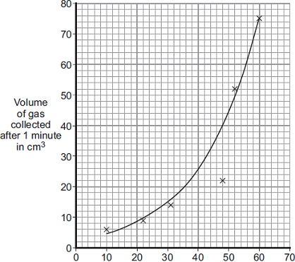
Temperature of acid in °C

One of the results on the graph is anomalous.

(i) Draw a circle on the graph around the anomalous point.

(1)

(ii) Suggest what may have happened to cause this anomalous result.

Explain your answer.

______________________________________________________________

______________________________________________________________

______________________________________________________________

______________________________________________________________

(2)

(d) Explain how the student could improve the accuracy of the volume of gas recorded at each temperature.

___________________________________________________________________

___________________________________________________________________

___________________________________________________________________

___________________________________________________________________

___________________________________________________________________

(3)

(e) The student then used the same apparatus to measure the volume of gas produced every 10 seconds at 40 °C.

The student’s results are shown on the graph.

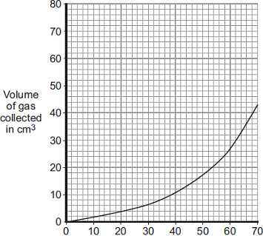
Time in seconds

The rate at which the gas was produced got faster over the first 60 seconds.

The student’s teacher gave two possible explanations of why the reaction got faster.

Explanation 1
There was a layer of magnesium oxide on the surface of the magnesium.
The layer of magnesium oxide prevented the magnesium reacting with the acid.
As the magnesium oxide reacted slowly with the acid, the magnesium was exposed to the acid and hydrogen gas was produced.

Explanation 2
The reaction is exothermic, and so the temperature of the acid increased during the reaction.

(i) Describe further experimental work the student could do to see if Explanation 1 is correct.

______________________________________________________________

______________________________________________________________

______________________________________________________________

______________________________________________________________

(2)

(ii) Describe further experimental work the student could do to see if Explanation 2 is correct.

______________________________________________________________

______________________________________________________________

______________________________________________________________

______________________________________________________________

(2)

- A student investigated the effect of temperature on the rate of a reaction.

The picture below shows an experiment.

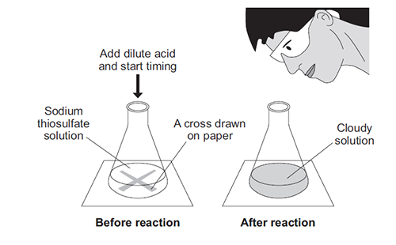

The student:

• put sodium thiosulfate solution into a conical flask

• heated the sodium thiosulfate solution to the required temperature

• put the flask on a cross drawn on a piece of paper

• added dilute hydrochloric acid and started a stopclock

• stopped the stopclock when the cross could no longer be seen

• repeated the experiment at different temperatures.

The equation for the reaction is:

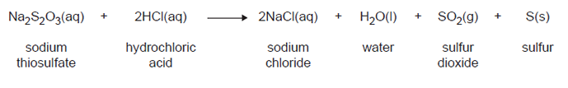

(a) Explain why the solution goes cloudy.

___________________________________________________________________

___________________________________________________________________

___________________________________________________________________

(2)

(b) Give two variables the student must control to make the investigation a fair test.

1. _________________________________________________________________

2. _________________________________________________________________

(2)

(c) State the effect that increasing the temperature of the sodium thiosulfate solution has on the rate of the reaction.

Explain this effect in terms of particles and collisions.

___________________________________________________________________

___________________________________________________________________

___________________________________________________________________

___________________________________________________________________

___________________________________________________________________

___________________________________________________________________

___________________________________________________________________

___________________________________________________________________

(4)

(d) Suggest how the student should change the method to investigate the rate of reaction at 5°C.

___________________________________________________________________

___________________________________________________________________ (1)
Required Practical 4: Chromatography

Investigate how paper chromatography can be used to separate and tell the difference between coloured substances.
- A student investigated a food colouring using paper chromatography.

This is the method used.

1. Put a spot of food colouring X on the start line.

2. Put spots of three separate dyes, A, B and C, on the start line.

3. Place the bottom of the paper in water and leave it for several minutes.

(a) Figure 1 shows the apparatus the student used.

Figure 1

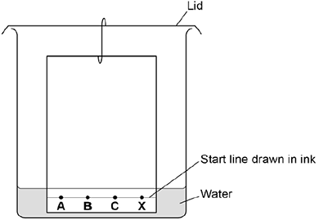

Give two mistakes the student made in setting up the experiment.

Tick two boxes.
The lid was on the beaker.
The paper did not touch the bottom of the beaker.
The spots were too small.
The start line was drawn in ink.
The water level was above the spots.

(2)

(b) Another student set the experiment up correctly.

Figure 2 shows the student’s results.

Figure 2

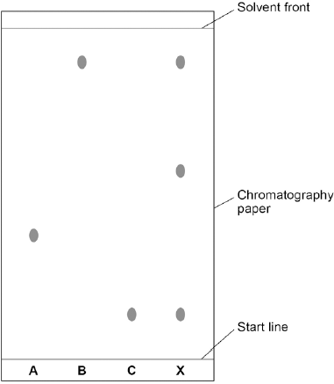

How many dyes were in X?

Tick one box.

1 |  |  | 3 |  |  | 4 |  |  | 6

(1)

(c) Which dye, A, B or C, is not in X?

Write your answer in the box.

(1)

(d) Use Figure 2 to complete the table below.

Calculate the value for R_{f} for dye A.

 | Distance in mm
Distance moved by dye A | ______________
Distance from start line to solvent front | ______________

Use the equation:

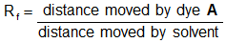

Give your answer to two significant figures.

___________________________________________________________________

___________________________________________________________________

___________________________________________________________________

R_{f} value = ________________________________

(5)
- Chromatography was carried out on a sample of soft drinks to check that they contained only colours that were safe. This is the result.

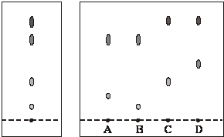

Safe colours Colours from the soft drinks

What conclusions about the safety of the colours in the soft drinks A, B, C and D can be made from the results shown by chromatography?

_______________________________________________________________________

_______________________________________________________________________

_______________________________________________________________________

_______________________________________________________________________

_______________________________________________________________________

(2)
- Read the article.

Problem food colourings
Scientists say they have evidence that some food colourings cause hyperactive behaviour in
young children. These food colourings are added to some sweets.

W, X, Y and Z are food colourings that may cause hyperactive behaviour in young children.

A scientist used chromatography to see if these food colourings were used in two sweets, S and P.

The results are shown on the chromatogram.

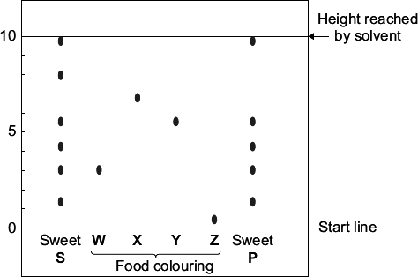

(a) Food colourings, such as W, X, Y and Z, are added to some sweets.

Suggest one reason why.

___________________________________________________________________

___________________________________________________________________

(1)

(b) In chromatography, the R_{f} value = 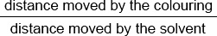

Use the scale on the chromatogram to help you to answer this question.

Which food colouring, W, X, Y or Z, has an R_{f} value of 0.7?

(1)

(c) From the chromatogram, what conclusions can the scientist make about the colourings in sweets S and P?

___________________________________________________________________

___________________________________________________________________

___________________________________________________________________

___________________________________________________________________

___________________________________________________________________

___________________________________________________________________

___________________________________________________________________ (3)
Required Practical 5: Water Purification
Analysis and purification of water samples from different sources. To include pH measurement, removal of dissolved solids and distillation.
- Some countries make drinking water from sea water.
- Complete the figure below to show how you can distil salt solution to produce and collect pure water.

Label the following:

• pure water

• salt solution

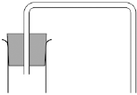

(3)

(b) How could the water be tested to show it is pure?

Give the expected result of the test for pure water.

___________________________________________________________________

___________________________________________________________________

___________________________________________________________________

___________________________________________________________________

___________________________________________________________________

(2)

(c) Why is producing drinking water from sea water expensive?

___________________________________________________________________

___________________________________________________________________

(1)

- Good quality water is needed for a healthy life.

In the United Kingdom, obtaining safe water for drinking is as simple as turning on a tap.
The water is made safe to drink by water companies.

However, in many parts of Africa and Asia, water used for drinking is contaminated and untreated. It is estimated that 2.2 million people die each year as a result of drinking contaminated water.

Efforts are being made to solve this problem and more water is being treated.

Describe how water in the United Kingdom is treated.

Explain how this makes it safe to drink.

_______________________________________________________________________

_______________________________________________________________________

_______________________________________________________________________

_______________________________________________________________________

_______________________________________________________________________

_______________________________________________________________________

_______________________________________________________________________

_______________________________________________________________________

(3)
- The diagram shows a water filter used in the home.

Water in
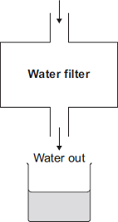
- A student collected a sample of water from the filter.

The student could show that the filtered water contains dissolved salts without using a chemical test.

Describe how.

___________________________________________________________________

___________________________________________________________________

___________________________________________________________________

___________________________________________________________________

___________________________________________________________________

___________________________________________________________________

(2)

(b) Seawater is forced through a membrane to make drinking water.

Seawater
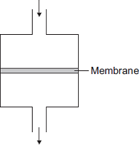
Drinking water

Suggest why water molecules can pass through the membrane, but sodium ions and chloride ions cannot.

___________________________________________________________________

___________________________________________________________________

(1)

- Rock salt is a mixture of sand and salt.

Salt dissolves in water. Sand does not dissolve in water.

Some students separated rock salt. This is the method used.

1. Place the rock salt in a beaker.

2. Add 100 cm³ of cold water.

3. Allow the sand to settle to the bottom of the beaker.

4. Carefully pour the salty water into an evaporating dish.

5. Heat the contents of the evaporating dish with a Bunsen burner until salt crystals start to form.

(a) Suggest one improvement to step 2 to make sure all the salt is dissolved in the water.

___________________________________________________________________

___________________________________________________________________

(1)

(b) The salty water in step 4 still contained very small grains of sand.

Suggest one improvement to step 4 to remove all the sand.

___________________________________________________________________

___________________________________________________________________

(1)

(c) Suggest one safety precaution the students should take in step 5.

___________________________________________________________________

___________________________________________________________________

(1)

(d) Another student removed water from salty water using the apparatus in the figure below.

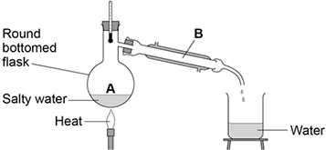

Describe how this technique works by referring to the processes at A and B.

___________________________________________________________________

___________________________________________________________________

___________________________________________________________________

___________________________________________________________________

(2)

(e) What is the reading on the thermometer during this process?

__________________ °C

(1)

Required Practical 6: Electrolysis

Investigate what happens when aqueous solutions are electrolysed using inert electrodes.

- This question is about zinc and magnesium.

Zinc is produced by electrolysis of molten zinc chloride, as shown in the figure below.

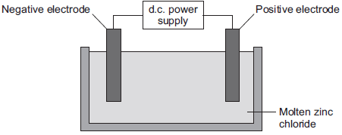

(a) (i) Why must the zinc chloride be molten for electrolysis?

______________________________________________________________

______________________________________________________________

(1)

(ii) Describe what happens at the negative electrode.

______________________________________________________________

______________________________________________________________

______________________________________________________________

______________________________________________________________

______________________________________________________________

______________________________________________________________

(3)

(iii) Complete the half equation for the reaction at the positive electrode.

________ Cl₂ + ________ e–

(1)

(b) Magnesium can be produced from magnesium oxide.

The equation for the reaction is:

Si(s) + 2 MgO(s) SiO₂(s) + 2 Mg(g)

(i) How can you tell from the equation that the reaction is done at a high temperature?

______________________________________________________________

______________________________________________________________

(1)

(ii) This reaction to produce magnesium from magnesium oxide is endothermic.

What is meant by an endothermic reaction?

______________________________________________________________

______________________________________________________________

(1)

(iii) A company made magnesium using this reaction.

Calculate the mass of magnesium oxide needed to produce 1.2 tonnes of magnesium.

Relative atomic masses (A_{r}): O = 16; Mg = 24

______________________________________________________________

______________________________________________________________

______________________________________________________________

______________________________________________________________

Mass of magnesium oxide needed = ____________________ tonnes

(3)

(iv) The company calculated that they would produce 1.2 tonnes of magnesium, but only 0.9 tonnes was produced.

Calculate the percentage yield.

______________________________________________________________

______________________________________________________________

Percentage yield = __________ %

(1)

(v) Give one reason why the calculated yield of magnesium might not be obtained.

______________________________________________________________

______________________________________________________________

(1)

- Two experiments were set up as shown.

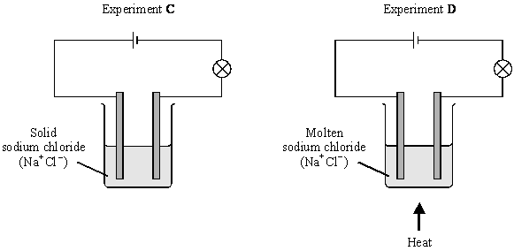

(i) Give two observations which would be seen only in Experiment D.

1. ____________________________________________________________

2. ____________________________________________________________

(2)

(ii) Explain why in Experiment C no changes would be seen.

______________________________________________________________

______________________________________________________________

______________________________________________________________

______________________________________________________________

(2)

(b) Another electrolysis experiment used an aqueous solution of copper chloride.

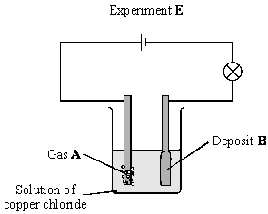

(i) What does electrolysis mean?

______________________________________________________________

______________________________________________________________

______________________________________________________________

(2)

(ii) Name the gas A and the deposit B.

Gas A ________________________________________________________

______________________________________________________________

(2)

(c) Give one industrial use of electrolysis.

___________________________________________________________________

(1)
- Sodium hydroxide, hydrogen and chlorine can all be made in one industrial process. Electricity is passed through aqueous sodium chloride solution (brine). The diagram below shows a cell that can be used for this process.

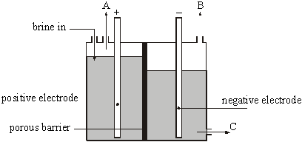

(a) Name A, B and C.

Gas A _____________________________________________________________

Gas B _____________________________________________________________

Solution C _________________________________________________________

(2)

(b) Balance the equations for the reactions at the electrodes.

(i) _____ Cl– – ______ e– → Cl₂

(ii) _____ H⁺ + ______ e– → H₂

(2)

(c) Name the compound in this cell which produces the hydrogen ions.

___________________________________________________________________

(1)

(d) Which type of particles must be able to pass through the barrier to allow the electrolysis to take place?

___________________________________________________________________

(1)

Required Practical 7: Neutralisation

Determination of the reacting volumes of solutions of a strong acid and a strong alkali by titration.

- Sodium hydroxide neutralises sulfuric acid.

The equation for the reaction is:

2NaOH + H₂SO₄ → Na₂SO₄ + 2H₂O

(a) Sulfuric acid is a strong acid.

What is meant by a strong acid?

___________________________________________________________________

___________________________________________________________________

___________________________________________________________________

(2)

(b) Write the ionic equation for this neutralisation reaction. Include state symbols.

___________________________________________________________________

(2)

(c) A student used a pipette to add 25.0 cm³ of sodium hydroxide of unknown concentration to a conical flask.

The student carried out a titration to find out the volume of 0.100 mol / dm³ sulfuric acid needed to neutralise the sodium hydroxide.

Describe how the student would complete the titration.

You should name a suitable indicator and give the colour change that would be seen.

___________________________________________________________________

___________________________________________________________________

___________________________________________________________________

___________________________________________________________________

___________________________________________________________________

___________________________________________________________________

___________________________________________________________________

___________________________________________________________________

___________________________________________________________________

___________________________________________________________________

(4)

(d) The student carried out five titrations. Her results are shown in the table below.

 | Titration 1 | Titration 2 | Titration 3 | Titration 4 | Titration 5
Volume of 0.100 mol / dm³ sulfuric acid in cm³ | 27.40 | 28.15 | 27.05 | 27.15 | 27.15

Concordant results are within 0.10 cm³ of each other.

Use the student’s concordant results to work out the mean volume of 0.100 mol / dm³sulfuric acid added.

___________________________________________________________________

___________________________________________________________________

Mean volume = _____________________________ cm³

(2)

(e) The equation for the reaction is:

2NaOH + H₂SO₄ → Na₂SO₄ + 2H₂O

Calculate the concentration of the sodium hydroxide.

Give your answer to three significant figures.

___________________________________________________________________

___________________________________________________________________

___________________________________________________________________

___________________________________________________________________

Concentration = _______________________ mol / dm³

(4)

(f) The student did another experiment using 20 cm³ of sodium hydroxide solution with a concentration of 0.18 mol / dm³.

Relative formula mass (M_{r}) of NaOH = 40

Calculate the mass of sodium hydroxide in 20 cm³ of this solution.

___________________________________________________________________

___________________________________________________________________

___________________________________________________________________

___________________________________________________________________

Mass = ________________ g

(2)
- In this question you will be assessed on using good English, organising information clearly and using specialist terms where appropriate.

A student has to check if two samples of hydrochloric acid, A and B, are the same concentration.

Describe how the student could use the apparatus and the solutions in the diagram below to carry out titrations.

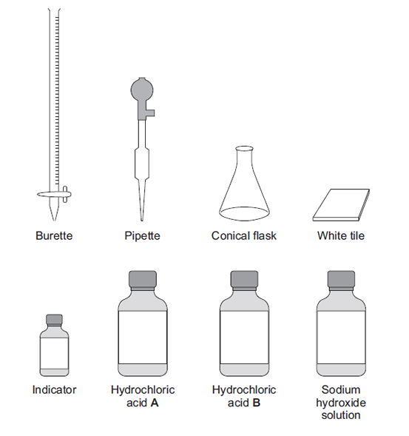

___________________________________________________________________

___________________________________________________________________

___________________________________________________________________

___________________________________________________________________

___________________________________________________________________

___________________________________________________________________

___________________________________________________________________

___________________________________________________________________

___________________________________________________________________

___________________________________________________________________

___________________________________________________________________

(6)

Required Practical 8: Identifying Ions

Use of chemical tests to identify the ions in unknown single ionic compounds covering the ions from Flame tests and sulphates.
- In this question you will be assessed on using good English, organising information clearly and using specialist terms where appropriate.

A group of students had four different colourless solutions in beakers 1, 2, 3 and 4, shown in the figure below.

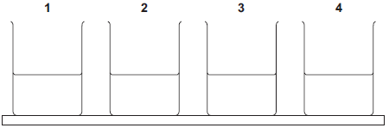

The students knew that the solutions were

• sodium chloride

• sodium iodide

• sodium carbonate

• potassium carbonate

but did not know which solution was in each beaker.

The teacher asked the class to plan a method that could be used to identify each solution.

She gave the students the following reagents to use:

• dilute nitric acid

• silver nitrate solution.

The teacher suggested using a flame test to identify the positive ions.

Outline a method the students could use to identify the four solutions.

You should include the results of the tests you describe.

_______________________________________________________________________

_______________________________________________________________________

_______________________________________________________________________

_______________________________________________________________________

_______________________________________________________________________

_______________________________________________________________________

_______________________________________________________________________

_______________________________________________________________________

_______________________________________________________________________

_______________________________________________________________________

_______________________________________________________________________

_______________________________________________________________________

_______________________________________________________________________

_______________________________________________________________________

_______________________________________________________________________

_______________________________________________________________________

_______________________________________________________________________

_______________________________________________________________________

_______________________________________________________________________

_______________________________________________________________________

_______________________________________________________________________

(6)
- Flame emission spectroscopy can be used to analyse metal ions in solution.

Figure 3 gives the flame emission spectra of five metal ions, and of a mixture of two metal ions.

Figure 3

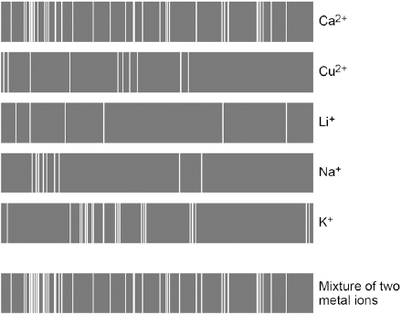
- Use the spectra to identify the two metal ions in the mixture.

___________________________________________________________________

___________________________________________________________________

(2)

(b) Explain why a flame test could not be used to identify the two metal ions in the mixture.

___________________________________________________________________

___________________________________________________________________

___________________________________________________________________

___________________________________________________________________

(2)

(c) Two students tested a green compound X.

The students added water to compound X.

Compound X did not dissolve.

The students then added a solution of ethanoic acid to compound X.

A gas was produced which turned limewater milky.

Student A concluded that compound X was sodium carbonate.

Student B concluded that compound X was copper chloride.

Which student, if any, was correct?

Explain your reasoning.

___________________________________________________________________

___________________________________________________________________

___________________________________________________________________

___________________________________________________________________

___________________________________________________________________

___________________________________________________________________

___________________________________________________________________

___________________________________________________________________

(4)

