GCSE Physics Trilogy (F)
Required Practical Question Book

Name: | Class: | Teacher:

Practical 1  Specific Heat Capacity | / 19 | Practical 5  Force and Extension | / 15
Practical 2  Resistance | / 16 | Practical 6  Acceleration | / 18
Practical 3  I-V Characteristics | / 18 | Practical 7  Waves | / 8
Practical 4  Density | / 13 | Practical 8  Radiation and absorption | / 12

Required Practical 1: Specific Heat Capacity
An investigation to determine the specific heat capacity of one or more materials.
- A student investigated how much energy from the Sun was incident on the Earth’s surface at her location.

She put an insulated pan of water in direct sunlight and measured the time it took for the temperature of the water to increase by 0.6 °C.

The apparatus she used is shown in the figure below.

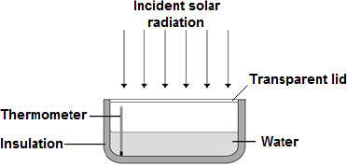

(a) Choose the most appropriate resolution for the thermometer used by the student.

Tick one box.
0.1 °C
0.5 °C
1.0 °C

(1)

(b) The energy transferred to the water was 1050 J.

The time taken for the water temperature to increase by 0.6 °C was 5 minutes.

The specific heat capacity of water is 4200 J / kg °C.

Write down the equation which links energy transferred, power and time.

___________________________________________________________________

(1)

(c) Calculate the mean power supplied by the Sun to the water in the pan.

___________________________________________________________________

___________________________________________________________________

___________________________________________________________________

Average power = _______________________ W

(2)

(d) Calculate the mass of water the student used in her investigation.

Use the correct equation from the Physics Equation Sheet.

___________________________________________________________________

___________________________________________________________________

___________________________________________________________________

Mass = _______________________ kg

(3)

(e) The student’s results can only be used as an estimate of the mean power at her location.

Give one reason why.

___________________________________________________________________

___________________________________________________________________

(1)

- A student used the apparatus in Figure 1 to compare the energy needed to heat blocks of different materials.

Each block had the same mass.

Each block had holes for the thermometer and the immersion heater.

Each block had a starting temperature of 20 °C.

Figure 1

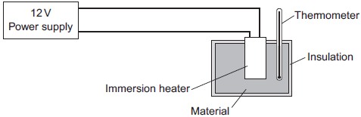

The student measured the time taken to increase the temperature of each material by 5 °C.

(a) (i) State two variables the student controlled.

1. ____________________________________________________________

2. ____________________________________________________________

(2)

Figure 2 shows the student’s results.

Figure 2

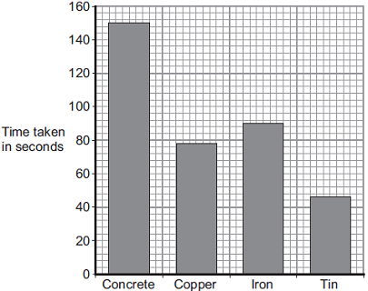
Material

(ii) Why was a bar chart drawn rather than a line graph?

______________________________________________________________

______________________________________________________________

(1)

(iii) Which material was supplied with the most energy?

______________________________________________________________

Give the reason for your answer.

______________________________________________________________

______________________________________________________________

(2)

(iv) The iron block had a mass of 2 kg.

Calculate the energy transferred by the heater to increase the temperature of the iron block by 5 °C.

The specific heat capacity of iron is 450 J / kg °C.

______________________________________________________________

______________________________________________________________

______________________________________________________________

Energy transferred = ______________________________ J

(2)

(b) The student used the same apparatus to heat a 1 kg block of aluminium.

He recorded the temperature of the block as it was heated from room temperature.

The results are shown in Figure 3.

Figure 3

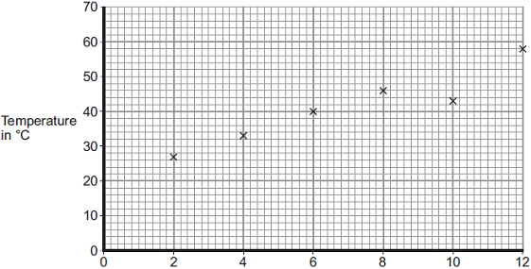
Time the immersion heater is switched on for in minutes

(i) One of the student’s results is anomalous.

Draw a ring around the anomalous result.

(1)

(ii) Draw the line of best fit for the points plotted in Figure 3.

(1)

(iii) What was the temperature of the room?

Temperature = _______________ °C

(1)

(iv) What was the interval of the time values used by the student?

Interval = _______________ minutes

(1)

Required Practical 2: Resistance
Use circuit diagrams to set up and check appropriate circuits to investigate the factors affecting the
resistance of electrical circuits.

- A student wants to investigate how the current through a filament lamp affects its resistance.

(a) Use the circuit symbols in the boxes to draw a circuit diagram that she could use.

12 V battery | variable  resistor | filament  lamp | voltmeter | ammeter
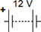

(2)

(b) Describe how the student could use her circuit to investigate how the current through a filament lamp affects its resistance.

___________________________________________________________________

___________________________________________________________________

___________________________________________________________________

___________________________________________________________________

___________________________________________________________________

___________________________________________________________________

___________________________________________________________________

___________________________________________________________________

(4)

(c) The student’s results are shown in Figure 1.

Figure 1

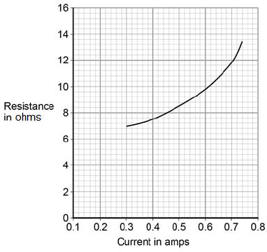

Describe how the resistance of the filament lamp changes as the current through it increases.

___________________________________________________________________

___________________________________________________________________

(1)

(d) Use Figure 1 to estimate the resistance of the filament lamp when a current of 0.10 A passes through the lamp.

Resistance = _____________________ Ω

(1)

(e) The current-potential difference graphs of three components are shown in Figure 2.

Use answers from the box to identify each component.

diode | filament lamp | light dependent resistor
resistor at constant temperature |  | thermistor

Figure 2

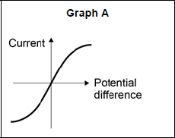 __________________________

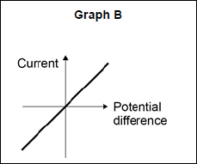 __________________________

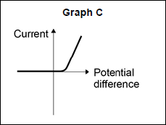 __________________________

(3)

- A resistor is a component that is used in an electric circuit.

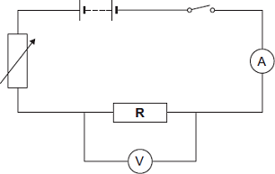

(i) Describe how a student would use the circuit to take the readings necessary to determine the resistance of resistor R.

______________________________________________________________

______________________________________________________________

______________________________________________________________

______________________________________________________________

______________________________________________________________

______________________________________________________________

______________________________________________________________

______________________________________________________________

______________________________________________________________

______________________________________________________________

______________________________________________________________

______________________________________________________________

______________________________________________________________

______________________________________________________________

(6)

Required Practical 3: I-V Characteristics
Use circuit diagrams to construct appropriate circuits to investigate the I–V characteristics of a variety of circuit elements, including a filament lamp, a diode and a resistor at constant temperature.
- The diagram shows an electronic circuit.

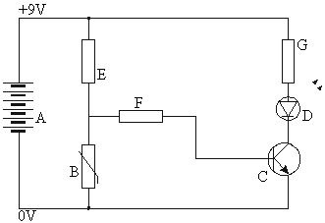

(a) Write down the names of the components in the list below.

A = _____________________________________________

B = _____________________________________________

C = _____________________________________________

D = _____________________________________________

E, F and G = _____________________________________________

(5)

(b) The graph shows how the resistance of component B depends on its temperature.

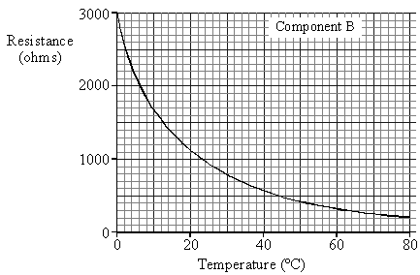

Describe, in as much detail as you can, how the resistance of component B changes as its temperature rises from 0ºC to 80ºC.

___________________________________________________________________

___________________________________________________________________

___________________________________________________________________

___________________________________________________________________

___________________________________________________________________

(4)

(c) At what temperature does component B have a resistance of 1000 ohms?

Answer _____________________ °C .

(2)

- A student used the apparatus below to find out how the resistance of a light-dependent resistor (LDR) depends on light intensity.

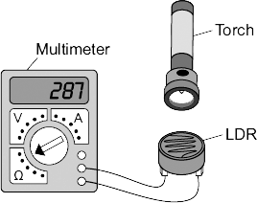

The resistance of the LDR was measured directly using a multimeter.

(a) (i) Which one of the following is the correct circuit symbol for a LDR?

Draw a ring around your answer.

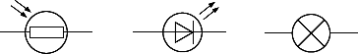

(1)

(ii) Name one factor that will affect the intensity of the light hitting the LDR.

______________________________________________________________

______________________________________________________________

(1)

(b) The manufacturer of the LDR provides data for the LDR in the form of a graph.

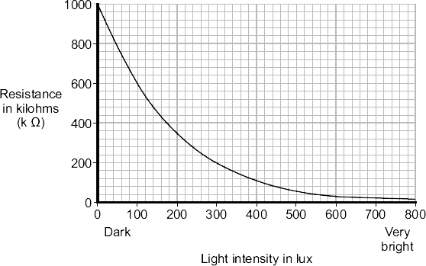

Describe how the resistance of the LDR changes when the light intensity increases from 100 lux to 300 lux.

___________________________________________________________________

___________________________________________________________________

___________________________________________________________________

(2)

(c) The student only obtained three results. These are given in the table.

Light intensity | Resistance in kilohms
Dark | 750
Bright | 100
Very bright | 1

(i) The student could not use the results to draw a line graph.
Why not?

______________________________________________________________

______________________________________________________________

(1)

(ii) Do the student’s results agree with the data the manufacturer provided?

Draw a ring around your answer. | YES | NO

Give a reason for your answer.

______________________________________________________________

______________________________________________________________

______________________________________________________________

(1)

(d) Which one of the following circuits probably includes a LDR?

Tick () one box.

A circuit that automatically switches outside lights on when it gets dark.
A circuit that automatically switches central heating on and off.
A circuit that automatically turns lights off when no one is in the room.

(1)

Required Practical 4: Density
Use appropriate apparatus to make and record the measurements needed to determine the densities of regular and irregular solid objects and liquids.
- A student wants to calculate the density of the two objects shown in the figure below.

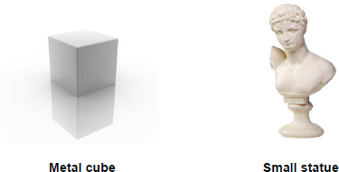

© Whitehoune/iStock/Thinkstock, © Marc Dietrich/Hemera/Thinkstock

Describe the methods that the student should use to calculate the densities of the two objects.

_______________________________________________________________________

_______________________________________________________________________

_______________________________________________________________________

_______________________________________________________________________

_______________________________________________________________________

_______________________________________________________________________

_______________________________________________________________________

_______________________________________________________________________

_______________________________________________________________________

_______________________________________________________________________

(6)

- The figure below shows a balloon filled with helium gas.

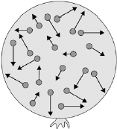

(a) Describe the movement of the particles of helium gas inside the balloon.

___________________________________________________________________

___________________________________________________________________

___________________________________________________________________

___________________________________________________________________

(2)

(b) What name is given to the total kinetic energy and potential energy of all the particles of helium gas in the balloon?

Tick one box.
External energy
Internal energy
Movement energy

(1)

(c) Write down the equation which links density, mass and volume.

___________________________________________________________________

(1)

(d) The helium in the balloon has a mass of 0.00254 kg.

The balloon has a volume of 0.0141 m³.

Calculate the density of helium. Choose the correct unit from the box.

m³ / kg kg / m³ kg m³

___________________________________________________________________

___________________________________________________________________

___________________________________________________________________

___________________________________________________________________

Density = __________________ Unit _________

(3)

Required Practical 5: Force and Extension
Investigate the relationship between force and extension for a spring.

- A student suspended a spring from a laboratory stand and then hung a weight from the spring. Figure 1 shows the spring before and after the weight is added.

Figure 1

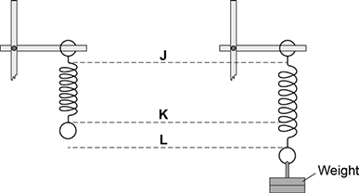

(a) Which distance gives the extension of the spring?

Tick one box.
from J to K
from K to L
from J to L

(1)

(b) The student used the spring, a set of weights and a ruler to investigate how the extension of the spring depended on the weight hanging from the spring.

Figure 2 shows that the ruler is in a tilted position and not upright as it should be.

Figure 2

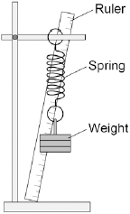

How would leaving the ruler tilted affect the weight and extension data to be recorded by the student?

Use answers from the box to complete each sentence.

Each answer may be used once, more than once or not at all.

greater than | the same as | smaller than

The weight recorded by the student would be _____________________ the actual weight.

The extension recorded by the student would be _____________________ the actual extension of the spring.

(2)

(c) The student moves the ruler so that it is upright and not tilted.

The student then completed the investigation and plotted the data taken in a graph.

The student’s graph is shown in Figure 3.

Figure 3

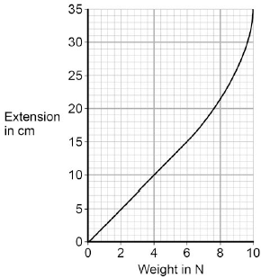

Use Figure 3 to determine the additional force needed to increase the extension of the spring from 5cm to 15cm.

Additional force = ______________________ N

(1)

(d) What can you conclude from Figure 3 about the limit of proportionality of the spring?

(1)

(e) The student repeated the investigation with three more springs, K, L and M.

The results for these springs are given in Figure 4.

Figure 4

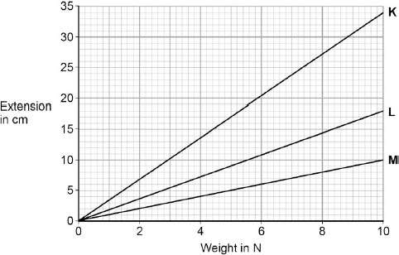

All three springs show the same relationship between the weight and extension.

What is that relationship?

Tick one box.
The extension increases non-linearly with the increasing weight.
The extension is inversely proportional to the weight.
The extension is directly proportional to the weight.

(1)

(f) Which statement, A, B or C, should be used to complete the sentence?

Write the correct letter, A, B or C, in the box below.

A a lower spring constant than

B the same spring constant as

C a greater spring constant than

From Figure 4 it can be concluded that spring M has the other two springs.

(1)

- A student investigated how the extension of a spring depends on the force applied to the spring.

The diagram shows the spring before and after a force had been applied.

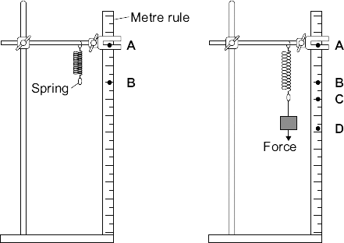

(a) (i) Complete the following sentence using letters, A, B, C or D, from the diagram.

The extension of the spring is the distance between the positions labelled

___________and ___________ on the metre rule.

(1)

(ii) What form of energy is stored in the stretched spring?

______________________________________________________________

(1)

(b) The results from the investigation are plotted on the following graph.

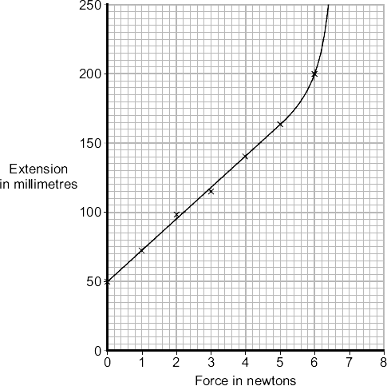

(i) The graph shows that the student has made an error throughout the investigation.

What error has the student made?

______________________________________________________________

______________________________________________________________

Give the reason for your answer.

______________________________________________________________

______________________________________________________________

(2)

(ii) The student has loaded the spring beyond its limit of proportionality.

Mark on the graph line the limit of proportionality of the spring. Label the point P.

Give the reason for choosing your point P.

______________________________________________________________

______________________________________________________________

______________________________________________________________

(2)

(c) The student uses a different spring as a spring balance. When the student hangs a stone from this spring, its extension is 72 mm.

The spring does not go past the limit of proportionality.

Calculate the force exerted by the stone on the spring.

spring constant = 25 N/m

Show clearly how you work out your answer.

___________________________________________________________________

___________________________________________________________________

Force = _________________________ N

(2)

Required Practical 6: Acceleration
Investigate the effect of varying the force on the acceleration of an object of constant mass, and the effect of varying the mass of an object on the acceleration produced by a constant force.

- The figure below shows the horizontal forces acting on a car.

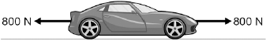

(a) Which one of the statements describes the motion of the car?

Tick one box.
It will be slowing down.
It will be stationary.
It will have a constant speed.
It will be speeding up.

(1)

(b) During part of the journey the car is driven at a constant speed for five minutes.

Which one of the equations links distance travelled, speed and time?

Tick one box.
distance travelled = speed + time
distance travelled = speed × time
distance travelled = speed − time
distance travelled = speed ÷ time

(1)

(c) During a different part of the journey the car accelerates from 9m / s to 18m / s in 6 s.

Use the following equation to calculate the acceleration of the car.

acceleration=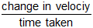

___________________________________________________________________

___________________________________________________________________

acceleration = _________________________ m / s²

(2)

(d) Which equation links acceleration, mass and resultant force?

Tick one box.
resultant force = mass + acceleration
resultant force = mass × acceleration
resultant force = mass − acceleration
resultant force = mass ÷ acceleration

(1)

(e) The mass of the car is 1120 kg. The mass of the driver is 80 kg.

Calculate the resultant force acting on the car and driver while accelerating.

___________________________________________________________________

___________________________________________________________________

Resultant force = _________________________ N

(2)

(f) Calculate the distance travelled while the car is accelerating.

Use the correct equation from the Physics Equation Sheet.

___________________________________________________________________

___________________________________________________________________

___________________________________________________________________

Distance = _________________________ m

(3)

(g) A car driver sees a fallen tree lying across the road ahead and makes an emergency stop.

The braking distance of the car depends on the speed of the car.

For the same braking force, explain what happens to the braking distance if the speed doubles.

You should refer to kinetic energy in your answer.

___________________________________________________________________

___________________________________________________________________

___________________________________________________________________

___________________________________________________________________

___________________________________________________________________

(4)

- A high-speed train accelerates at a constant rate in a straight line.

The velocity of the train increases from 30 m/s to 42 m/s in 60 seconds.

(a) (i) Calculate the change in the velocity of the train.

______________________________________________________________

Change in velocity = _______________ m/s

(1)

(ii) Use the equation in the box to calculate the acceleration of the train.

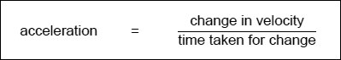

Show clearly how you work out your answer and give the unit.
Choose the unit from the list below.

m/s | m/s² | N/kg | Nm

______________________________________________________________

______________________________________________________________

Acceleration = _________________________

(2)

(b) Which one of the graphs, A, B or C, shows how the velocity of the train changes as it accelerates?

Write your answer, A, B or C, in the box.

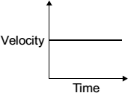  A | 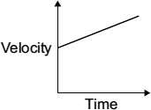  B | 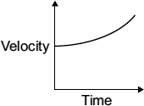  C

Graph (1)
Required Practical 7: Waves
Make observations to identify the suitability of apparatus to measure the frequency, wavelength and speed of waves in a ripple tank and waves in a solid and take appropriate measurements.
- The diagram shows a wave travelling along a rope.

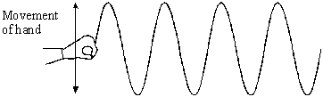

(a) On the diagram:

(i) show the wavelength and label it W;

(ii) show the amplitude and label it A.

(2)

(b) The wavelength of the wave is 0. I m. Its frequency is 2 Hz.

Calculate the speed of the wave. Show clearly how you work out your answer and give the unit.

___________________________________________________________________

___________________________________________________________________

Speed of wave _________________________________

(3)

- Small water waves are created in a ripple tank by a wooden bar. The wooden bar vibrates up and down hitting the surface of the water. Figure 9 shows a cross-section of the ripple tank and water.
- Which letter shows the amplitude of a water wave? Circle one letter.

J K L
(1)
(b) Describe how the wavelength of the water waves in a ripple tank can be measured accurately.

___________________________________________________________________

___________________________________________________________________

___________________________________________________________________

___________________________________________________________________

___________________________________________________________________ (2)

Required Practical 8: Radiation and Absorption
Investigate how the amount of infrared radiation absorbed or radiated by a surface depends on the nature of that surface.

- A student did two experiments on radiation. The apparatus he used is shown in the diagram.

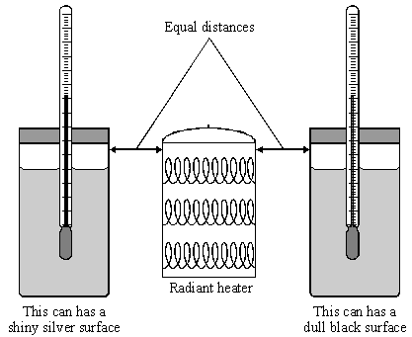

Experiment 1

• The student put the same volume of cold water into the two cans.

• He then switched on the heater.

• Ten minutes later the water in the can with the dull black surface was much hotter than the water in the other can.

Experiment 2

• The student filled both cans with boiling water.

• This time he left the heater off.

• Ten minutes later the water in the can with the dull black surface was much cooler than the water in the other can.

Use words from the box to complete the sentences.

absorber conductor emitter reflector

Experiment 1 shows that the dull black surface is a good ______________ of radiation

and that the shiny silver surface is a good _____________ of radiation.

Experiment 2 shows that the dull black surface is a good __________________ of radiation.

(3)

- (a) Use the words from the box to complete the following sentences.

conduction | convection | radiation

(i) The transfer of thermal energy (heat) by the movement of hot liquids

is called _______________________ .

(1)

(ii) The transfer of thermal energy (heat) from one particle to another

is called _______________________ .

(1)

(b) A student set up the following equipment. The 3 metal plates are the same distance from the heater. The surfaces of each of the 3 metal plates are different colours.

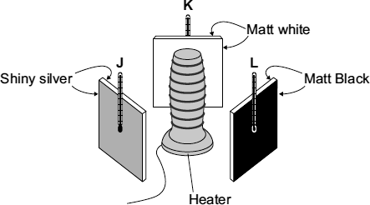

The student switched the heater on for 10 minutes. The thermometers were read before the heater was switched on. The thermometers were read again just after the heaters were switched off.
The readings are shown in the table.

 | Temperature before  switching on in °C | Temperature after  switching on in °C
1 | 19 | 21
2 | 19 | 29
3 | 19 | 23

(i) Which set of readings, 1, 2 or 3, is most likely to have been taken from the thermometer labelled L?

____________________

Give a reason for your answer.

______________________________________________________________

______________________________________________________________

(2)

(ii) Which one of the following was not a control variable in this experiment?

Put a tick () in the box next to your answer.

the distance between the heater and the metal plates

the power of the heater

the temperature before the heater was switched on

the colour of the metal plates

(1)

(iii) Suggest one advantage of using a temperature sensor, data logger and computer, rather than a thermometer to carry out this experiment.

______________________________________________________________

______________________________________________________________

(1)

(c) The picture shows a fire fighter putting out a forest fire. The fire fighter’s clothing has thick thermal padding inside and a light coloured, fire proof, shiny layer outside.

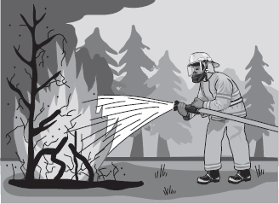

(i) What is the main way that heat is transferred through the air from the fire to the fire fighter?

______________________________________________________________

______________________________________________________________

(1)

(ii) Why is the outside layer of the clothing shiny?

______________________________________________________________

______________________________________________________________

(1)

(d) The graph shows the result of a laboratory test on two types of thermal padding. Each type of padding was put onto a very hot metal surface and the temperature inside the padding was taken every minute.

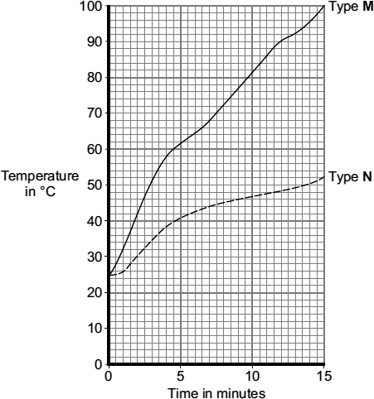

Which type of padding, M or N, would it be best to use inside the fire fighter’s clothing?

_____________________________________________

Give a reason for your answer.

___________________________________________________________________

___________________________________________________________________

(1)

