Percentages

- What does the word ‘percent’ mean?

- State the equation for calculating percentage change.

- For each of the following calculate the percentage increase.
Show all of your workings to an appropriate number of decimal places.

  - Start mass = 2.6g; Final mass = 2.7g 6. Start mass = 1.7g; Final mass = 2.3g
  - Start mass = 1.7g; Final mass = 1.9g 7. Start mass = 2.3g; Final mass = 2.6g
  - Start mass = 3.2g; Final mass = 3.7g 8. Start mass = 2.5g; Final mass = 2.6g
  - Start mass = 2.6g; Final mass = 2.9g 9. Start mass = 2.3g; Final mass = 2.7g
  - Start mass = 1.2g; Final mass = 1.5g 10. Start mass = 1.8g; Final mass = 2.1g
- For each of the following calculate the percentage decrease.
Show all of your workings to an appropriate number of decimal places.

  - Start mass = 2.6g; Final mass = 2.3g 6. Start mass = 1.7g; Final mass = 1.5g
  - Start mass = 2.9g; Final mass = 2.7g 7. Start mass = 2.3g; Final mass = 2.1g
  - Start mass = 2.6g; Final mass = 2.1g 8. Start mass = 2.1g; Final mass = 1.8g
  - Start mass = 1.6g; Final mass = 1.3g 9. Start mass = 1.8g; Final mass = 1.6g
  - Start mass = 1.2g; Final mass = 1.0g 10. Start mass = 3.1g; Final mass = 2.7g
- For each of the following calculate the percentage change.
Show all of your workings to an appropriate number of decimal places.

  - Start mass = 2.6g; Final mass = 2.9g 6. Start mass = 1.1g; Final mass = 1.5g
  - Start mass = 2.7g; Final mass = 2.7g 7. Start mass = 2.1g; Final mass = 2.7g
  - Start mass = 2.3g; Final mass = 2.1g 8. Start mass = 2.1g; Final mass = 2.8g
  - Start mass = 1.6g; Final mass = 1.8g 9. Start mass = 1.8g; Final mass =1.3g
  - Start mass = 1.2g; Final mass = 1.8g 10. Start mass = 3.2g; Final mass =2.7g
- Find the number from the following percentages.
Show all of your workings to 2 s.f.

  - What is 10% of 90?
  - What is 5% of 105?
  - What is 50% of 62?
  - What is 17% of 54?
  - What is 15% of 72?
  - What is 67% of 109.3?

Examination style questions

1 A student cut some cores from a turnip. They placed the cores into difference sugar concentrations to estimate the concentration of the solution inside the turnip cells.
Here are their results:
Concentration of sucrose solution/ M | Start mass/ g | Final mass/ g | Change in mass/ g | Percentage change in mass/ %
0.0 | 1.30 | 1.51
0.2 | 1.32 | 1.47
0.4 | 1.34 | 1.39
0.6 | 1.22 | 1.21
0.8 | 1.30 | 1.19
1.0 | 1.33 | 1.15

(a) Calculate the change in mass and percentage change in mass for each turnip core.
(b) Plot a graph of the percentage change in mass against the concentration of sucrose solution.
Your graph should include:
- A label for the x-axis
- Line of best fit

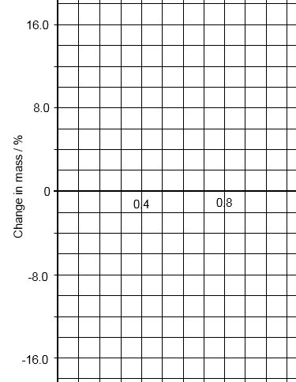
(c) Why calculate the percentage change in mass in addition to the change in mass?
.......................................................................................................................................

.......................................................................................................................................

.......................................................................................................................................

(d) Identify the anomalous result.

.......................................................................................................................................

.......................................................................................................................................

(e) Use the graph to estimate the concentration of the solution inside the turnip cells.

.......................................................................................................................................

.......................................................................................................................................

(e) Identify two possible sources of error in the investigation.

.......................................................................................................................................

.......................................................................................................................................

.......................................................................................................................................

.......................................................................................................................................

Answers

Percentages
a Out of 100
b % change = (Change ÷ Original) x 100
c (1) +3.8% (6) +35.3%
(2) +11.8% (7) +13.0%
(3) +15.6% (8) +4.0%
(4) +11.5% (9) +17.4%
(5) +25.0% (10) +16.7%
d (1) -11.5% (6) -11.8%
(2) -6.9% (7) -8.7%
(3) -19.2% (8) -14.3%
(4) -18.8% (9) -11.1%
(5) -16.7% (10) -12.9%
e (1) +11.5% (6) +36.4%
(2) 0% (7) +28.6%
(3) -8.7% (8) +33.3%
(4) +12.5% (9) -27.8%
(5) +50.0% (10) -15.6%
f (1) 9.0 (4) 9.2
(2) 5.3 (5) 11
(3) 31 (6) 73

Examination style questions
1 (a)

Concentration of sucrose solution/ M | Change in mass/ g | Percentage change in mass/ %
0.0 | 0.21 | +16.2
0.2 | 0.15 | +11.1
0.4 | 0.05 | +3.8
0.6 | -0.01 | -0.8
0.8 | -0.11 | -9.0
1.0 | -0.18 | -13.5

(b) Correct plot; labelled axes; line of best fit
(c) Allows comparison; different starting masses/ sizes
(d) 0.6M sucrose solution
(e) Concentration of solution; drying chops; accuracy of balance; water evaporation from solution.

