1 | What is the definition of density? | The amount of matter in a given volume.
2 | What is the word equation for density? | $$\text{density}=\frac{\text{mass}}{\text{volume}}$$
3 | What is the symbol equation for density? | $$ρ=\frac{m}{V}$$
4 | What are some common units of density? | kg/m³  g/cm³
5 | What is the particle model useful for? | The idea that solids, liquids and gases are all made up of particles in different arrangements is useful to explain the states of matter and the differences in their density: solids are more dense than gases as there are more particles in a given volume than gases have.
6 | Draw a particle diagram for solid, liquid and gas. | 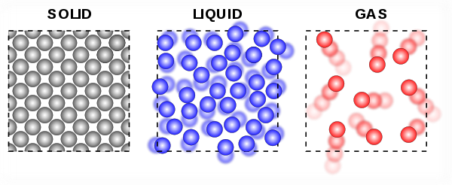
7 | Describe how to find the volume of a regular solid. | Use a ruler to measure the length, width and height of the object and use them to find the volume. Place the object on a balance to find the mass. Find the density by dividing the mass by the volume.
8 | Describe how to find the volume of an irregular solid, including a labelled diagram of the required equipment. | 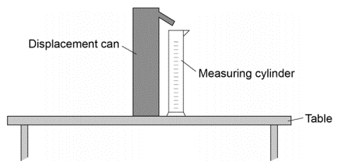  Place the object on a balance to find its mass. Fill a displacement can with water and let it drip until it no longer drips. Place the irregular object into the displacement can with a measuring cylinder under the spout. The volume of water that is displaced out of the can by the object is the same as the volume of the object. find the density by dividing the mass by the volume.
9 | What other equipment could be used to measure length, if required to a more precise value? | A micrometre or a set of Vernier callipers.
10 | When is mass conserved? | Always during changes of state; melting, freezing, boiling, evaporating, condensing and subliming.
11 | What makes a change of state different to a chemical change? | They are physical changes, so the material will recover its original properties if the change is reversed.
12 | What is internal energy? | The total kinetic energy and potential energy stored inside a system by the particles (atoms and molecules) that make up the system.
13 | How does heating an object change the internal energy? | It increases the energy of the particles that make up the system to either increase the temperature or cause a change of state.
14 | What does the increase in temperature of a system depend on? | The mass of the substance, the type of material and the energy input.
15 | What is the word equation that relates the change in thermal energy of a system to the factors that it depends upon? | $$\text{change in thermal energy} = \text{mass}×\text{specific heat capacity}×\text{temperature change}$$
16 | What is the symbol equation that relates the change in thermal energy of a system to the factors that it depends upon? | $$∆E = m c ∆θ$$
17 | What are the units of specific heat capacity? | J/kg °C
18 | What is the specific heat capacity of a substance? | The specific heat capacity of a substance is the amount of energy required to raise the temperature of 1 kg of the substance by 1 °C.
19 | What is latent heat? | The energy needed for a substance to change state is called latent heat. When a change of state occurs, the energy supplied changes the energy stored (internal energy) but not the temperature.
20 | What is the specific latent heat of a substance? | The specific latent heat of a substance is the amount of energy required to change the state of 1 kg of the substance with no change in temperature.
21 | What is the word equation for the energy for a change of state? | energy for a change of state = mass × specific latent heat
22 | What is the symbol equation for the energy for a change of state? | $$E = m L$$
23 | What are the units of specific latent heat? | J/kg
24 | What is the specific latent heat of fusion? | It relates to the change of state from solid to liquid
25 | What is the specific latent heat of vaporisation? | It relates to the change of state from liquid to vapour
26 | Label this heating graph:  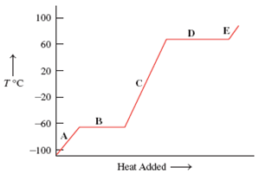 | A – solid  B – melting  C – liquid  D – vaporisation  E - gas
27 | What do the molecules of a gas do? | They move with constant random motion. Their kinetic energy is related to the temperature of the gas.
28 | A gas can be compressed or expanded by pressure changes. Where us the net force? | The pressure produces a net force at right angles to the wall of the gas container (or any surface).
29 | What equation relates the pressure and volume of a gas held at constant temperature? | $$\text{pressure}×\text{volume} = \text{cons}\text{tant}$$  $$\text{p V} = \text{constant}$$
30 | What are the units of pressure? | Pascals, Pa
31 | What is work? | The transfer of energy by a force.
32 | When work is done on a gas, what happens to the gas? | The internal energy increases and it can also cause an increase in temperature.

