1 | How big is the radius of an atom? | About 1 x 10⁻¹⁰ m
2 | What is the basic structure of an atom? | There is a positively charged nucleus (made up of protons and neutrons), surrounded by negatively charged electrons.
3 | Where is most of the mass of the atom? | In the nucleus
4 | How big is the radius of the nucleus? | It is less than 1/10,000th of the radius of the atom.
5 | What are energy levels? | The electrons are arranged at different distances from the nucleus in "energy levels" which are sometimes called "shells".
6 | What can cause the electron arrangements to change? | When electromagnetic radiation is absorbed, electrons move further from the nucleus to a higher energy level. If electromagnetic radiation is emitted, electrons move closer to the nucleus to a lower energy level.
7 | What is the overall charge of an atom? | It has no overall charge, so it is neutral.
8 | What is the number of electrons in an atom equal to? | The number of protons in the nucleus.
9 | All atoms of a particular element have the same… | number of protons.
10 | The number of protons in an atom is called the… | atomic number.
11 | The number of protons and neutrons in an atom is called the… | mass number…
12 | 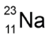  How many protons are in atoms of this element? | 11
13 | How many neutrons are in atoms of this element? | 12
14 | How many electrons are in atoms of this element? | 11
15 | What is an isotope? | Atoms of the same element with different numbers of neutrons.
16 | When an atom loses one or more outer electrons, what does it become? | A positive ion
17 | What may lead to a scientific model being changed or replaced? | New experimental evidence
18 | What did people think about atoms before the discovery of the electron? | They thought that atoms were tiny spheres that could not be divided.
19 | What model did the discovery of the electron lead to? | The plum pudding model
20 | What does this model suggest? | That an atom is a ball of positive charge with negative electrons embedded throughout (like plums in the pudding).
21 | What did the alpha particle scattering experiment show? | It showed at the mass of an atom was concentrated at the centre (the nucleus) which was positively charged.
22 | How did Niels Bohr adapt this model? | He suggested that electrons orbit the nucleus at specific distances?
23 | How did Bohr realise that his suggestions were correct? | His theoretical calculations agreed with experimental observations.
24 | What did later experiments show that led to the understanding of protons? | Scientists discovered that the positive charge of a nucleus can be divided into a whole number of smaller particles that each have the same positive charge.
25 | What did James Chadwick's experimental work show? | About 20 years after the understanding of the nucleus, he provided evidence of the existence of neutrons.
26 | What is radioactive decay? | Some atomic nuclei are unstable, so they give out radiation as they change to become more stable.
27 | What is the "activity" of a radioactive source? | It is the rate at which a source of unstable nuclei decays.
28 | What is the unit of activity? | Becquerel, Bq
29 | What is the count-rate? | It is the number of decays recorded each second by a detector (such as a Geiger-Muller tube).
30 | What are the 4 types of nuclear radiation? | alpha particles (α), beta particles (β), gamma rays (γ), neutrons (n).
31 | What do each of these consist of? | - an alpha particle (α) – this consists of two neutrons and two protons, it is the same as a helium nucleus  - a beta particle (β) – a high speed electron ejected from the nucleus as a neutron turns into a proton  - a gamma ray (γ) – electromagnetic radiation from the nucleus  - a neutron (n)
32 | What material is required to stop the penetration of each type? | Alpha - paper, beta - thin aluminium, gamma - thick lead
33 | Which type of nuclear radiation is the most and least ionising? | Most ionising - alpha, slightly ionising - beta, not ionising - gamma.
34 | Which type of nuclear radiation has the longest range in air? | Longest range - gamma, mid range - beta, very short range - alpha.
35 | State a use of alpha particles: | They are used in smoke alarms, as smoke particles will stop alpha particles from reaching a detector.
36 | State a use of beta particles: | Thickness monitoring of paper or aluminium sheets. The beta must be able to pass through the sheet to be detected and different amounts will be detected if the sheet is too thin or too thick.
37 | State a use for gamma rays: | They have several uses in medicine; the kill cancer cells, to sterilise medical equipment and in radioactive tracers.
38 | Why is ionising radiation dangerous? | It can damage the DNA in cells which can cause them to replicate uncontrollably into tumours.
39 | What is the difference between radioactive and radiation? | Radioactive - substances which emit nuclear radiation are radioactive. Radiation is the word for the alpha particles, beta particles and gamma rays that are emitted from radioactive substances.
40 | Why would radioactive sources used as tracers in the body need a short half life? | So that they don't remain radioactive for a long time inside the body as that would be dangerous.
41 | Why would radioactive sources used in appliances need a long half life? | So that they don’t need to be replaced so regularly.
42 | How is an alpha particle represented in a nuclear equation? | 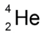
43 | How is a beta particle represented in a nuclear equation? | 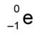
44 | What changes to the nucleus does emission of nuclear radiation cause? | Changes to the mass and/or charge of the nucleus.
45 | Write an equation for the alpha decay of radon-219. | 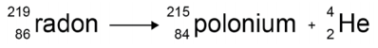
46 | Write an equation for the beta decay of carbon-14. | 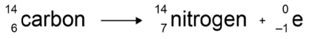
47 | What key word can be used to describe the nature of radioactive decay? | Random
48 | What is the half-life of a radioactive substance? | The half-life of a radioactive isotope is the time it takes for the number of nuclei of the isotope in a sample to halve, or the time it takes for the count rate (or activity) from a sample containing the isotope to fall to half its initial level.
49 | 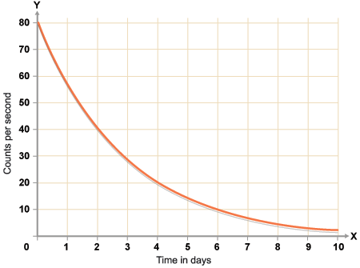  What is the half-life of this substance? | 2 days
50 | What is radioactive contamination? | Radioactive contamination is the unwanted presence of materials containing radioactive atoms on other materials. The hazard from contamination is due to the decay of the contaminating atoms. The type of radiation emitted affects the level of hazard.
51 | What is irradiation? | Irradiation is the process of exposing an object to nuclear radiation. The irradiated object does not become radioactive.
52 | What precautions should people take when working with radioactive substances? | Distance, gloves, suits, screens, minimise exposure time.
53 | Why is it important for the findings of studies into the effects of radiation on humans to be published and shared with other scientists? | So that the findings can be checked by peer-review and shared more widely if important.
54 | Where does background radiation come from? | Natural sources like rocks and cosmic rays from space. Man-made sources like nuclear weapons testing and nuclear accidents.
55 | What can affect the level of background radiation or a person's radiation dose? | Location or occupation
56 | What is the unit of radiation dose? | Sieverts, Sv
57 | How many millisieverts (mSv) make up 1 sievert (Sv)? | 1000 millisieverts (mSv) = 1 sievert (Sv)
58 | What medical uses are there for nuclear radiation? | Exploration of internal organs, control or destruction of unwanted tissue.
59 | What is nuclear fission? | Nuclear fission is the splitting of a large and unstable nucleus (eg uranium or plutonium).
60 | Spontaneous fission is rare. What must usually first happen for fission to occur? | It must absorb a neutron.
61 | What happens during nuclear fission? | The nucleus undergoing fission splits into two smaller nuclei, roughly equal in size, and emits two or three neutrons plus gamma rays. Energy is released by the fission reaction.
62 | What can happen with the neutrons that are released? | They can start a chain reaction.
63 | Draw a diagram to represent nuclear fission and show how a chain reaction might happen: | 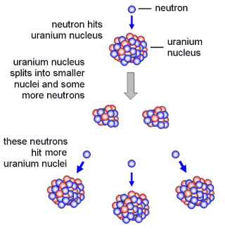
64 | What is nuclear fusion? | Nuclear fusion is the joining of two light nuclei to form a heavier nucleus. In this process some of the mass may be converted into the energy of radiation.

