1 | What is a scalar quantity? | It has magnitude (size) only. For example: time, voltage, energy.
2 | What is a vector quantity? | It has a magnitude and a direction. For example: velocity, force, displacement.
3 | We represent vectors with arrows. What do the length and direction of the arrow show? | The length represents the magnitude and the direction shows the direction of the vector.
4 | What is a force? | A force is a push or pull that acts on an object due to the interaction with another object.
5 | What is a contact force? | The objects are physically touching. For example: friction, air resistance, tension and normal contact force.
6 | What is a non-contact force? | The objects are physically separated. For example: gravitational force, electrostatic force and magnetic force.
7 | What is weight? | Weight is the force acting on an object due to gravity.
8 | What causes the gravitational force close to the Earth? | The gravitational field around the Earth.
9 | What does the weight of an object depend on? | The gravitational field strength at the point where the object is and the mass of the object.
10 | What is the word equation for weight? | $$\text{weight = mass × gravitational field strength}$$
11 | What is the symbol equation for weight? | $$W = m g$$
12 | What are the units of weight? | Newtons, N
13 | What are the units of gravitational field strength? | Newtons per kilogram, N/kg
14 | Where do we consider the weight of an object to act? | The centre of mass
15 | How is mass related to weight? | Mass is proportional to weight (m ∝ W)
16 | What instrument do we use to measure weight? | A newtonmeter (a calibrated spring-balance)
17 | What is a resultant force? | A number of forces acting on an object may be replaced by a single force that has the same effect as all the original forces acting together
18 | Draw and label the forces acting on a travelling boat:
19 | What does it mean to "resolve a force"? | A single force can be resolved into two components acting at right angles to each other. The two component forces together have the same effect as the single force.
20 | Find the resultant force R of these two forces:
21 | What do it mean that "work is done"? | When a force causes an object to move through a distance work is done on the object. So a force does work on an object when the force causes a displacement of the object.
22 | What is the word equation for work done? | work done = force × distance (moved along the line of action of the force)
23 | What is the symbol equation for work done? | $$W = F s$$
24 | What is the unit of work done? | Joules, J
25 | What is the equivalent unit? | 1 Joule = 1 Newton-metre
26 | When work is done against friction, what happens to the object? | It causes a rise in temperature of the object.
27 | Why must more than one force be applied to change the shape of an object? | A single force would cause the object to move.
28 | What is Hooke's Law? | The extension of an elastic object, such as a spring, is directly proportional to the force applied, provided that the limit of proportionality is not exceeded.
29 | What is the word equation for Hooke's Law? | $$\text{Force} = \text{spring constant} × \text{extension}$$
30 | What is the symbol equation for Hooke's Law? | $$F = k e$$
31 | What are the units of spring constant? | N/m
32 | How can we apply the equation to compression of an elastic object? | The relationship is the same, where "e" is in compression of the object.
33 | What is elastic potential energy related to? | A force that stretches (or compresses) a spring does work and elastic potential energy is stored in the spring.
34 | When work is done to stretch a spring, how much elastic potential energy is stored? | Provided that the spring is not inelastically deformed, the work done on the spring and the elastic potential energy stored are equal.
35 | What is the word equation for elastic potential energy? | $$\text{elastic potential energy} = 0.5 × \text{spring constant}×{\text{extension}}^{2}$$
36 | What is the symbol equation for elastic potential energy? | $$E_{e}=\frac{1}{2}ke^{2}$$
37 | What does the graph look like of force against extension when forces are applied to a spring? | 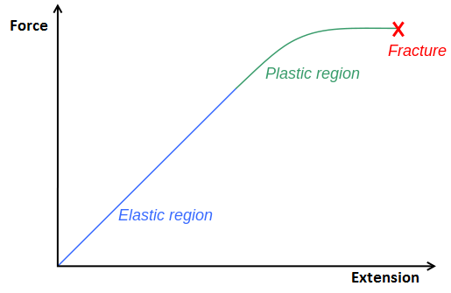
38 | How can the spring constant be extracted from this graph? | The spring constant is equal to the gradient of the graph.
39 | How can the elastic potential energy be extracted from this graph? | The area under the graph.
40 | In the required practical related to Hooke's Law, why should the extension of the spring be 0 m when no force is applied? | With no force applied, the spring is unstretched so has no extension. Any other value would be a measurement of length, not extension.
41 | What is the name for the turning effect of a force? | The turning effect of a force is called the moment of the force.
42 | What is the word equation for the moment of a force? | $$\text{moment of a force = force × distance}$$
43 | What is the symbol equation for the moment of a force? | $$M = F d$$
44 | What is the unit of moment of a force? | Newton-metres, Nm
45 | Where should the distance be measured? | The distance, d, is the perpendicular distance from the pivot to the line of action of the force, in metres, m.
46 | When an object is balanced, what can be said about the moments? | If an object is balanced, the total clockwise moment about a pivot equals the total anticlockwise moment about that pivot.
47 | What is the role of a lever? | Levers amplify the force applied.
48 | What is the role of a gear? | Gears change the force or rotational speed of a system.
49 | What is a fluid? | A liquid or a gas.
50 | What does the pressure in fluids cause? | The pressure in fluids causes a force normal (at right angles) to any surface.
51 | What is the word equation for the pressure in fluids? | $$\text{pressure} = \frac{\text{force normal to a surface} }{\text{area of that surface}}$$
52 | What is the symbol equation for the pressure in fluids? | $$p=\frac{F}{A}$$
53 | What are the units of pressure? | Pascals, Pa
54 | What is the word equation for the pressure due to a column of liquid? | $$\text{pressure}= \text{column}\text{ height} × \text{density of} \text{liquid} × \text{gravitational field strength}$$
55 | What is the symbol equation for the pressure due to a column of liquid? | $$p = h ρ g$$
56 | Why does the pressure at a point in a liquid increase with height of the column and density of liquid? | There is a greater mass of water above the point, applying a compression force.
57 | Where does upthrust come from? | A partially (or totally) submerged object experiences a greater pressure on the bottom surface than on the top surface. This creates a resultant force upwards; the upthrust.
58 | What is the atmosphere? | The atmosphere is a thin layer (relative to the size of the Earth) of air round the Earth.
59 | How does the atmosphere change? | The atmosphere gets less dense with increasing altitude.
60 | What causes atmospheric pressure? | Air molecules colliding with a surface create atmospheric pressure.
61 | Why does atmospheric pressure decrease with an increase in height? | The number of air molecules (and so the weight of air) above a surface decreases as the height of the surface above ground level increases. So as height increases there is always less air above a surface than there is at a lower height.
62 | What is distance? | Distance is a scalar quantity that describes how far an object moves.
63 | What is displacement? | Displacement includes both the distance an object moves, measured in a straight line from the start point to the finish point and the direction of that straight line. Displacement is a vector quantity.
64 | What is the typical walking speed? | 1.5 m/s
65 | What is the typical running speed? | 3 m/s
66 | What is the typical cycling speed? | 6 m/s
67 | What is the typical train speed? | 100 km/h
68 | What is the typical plane speed? | 900 km/h
69 | What may cause changes in the speed that a person can walk, run or cycle? | Age, terrain, fitness, distance travelled.
70 | What is the typical value for the speed of sound in air? | 330 m/s
71 | What piece of equipment can be used to measure distance? | Ruler, trundle-wheel
72 | What piece of equipment can be used to measure time? | Stop watch, light gates
73 | What the the word equation for calculating speed? | $$\text{distance travelled = speed × time}$$
74 | What the the symbol equation for calculating speed? | $$s = v t$$
75 | How is velocity different from speed? | Velocity is speed in a given direction.
76 | Why does motion in a circle involve changing velocity? | Moving in a circle involves constantly changing direction, so that means a changing velocity even when speed is constant.
77 | How can speed be calculated from a distance-time graph? | The gradient
78 | What does an accelerating object look like on a distance-time graph? | 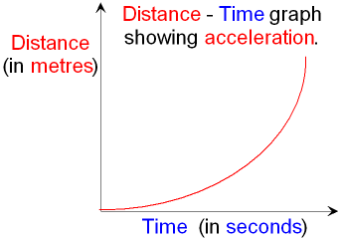
79 | How can the speed of an accelerating object be found from a distance-time graph at a particular time? | Draw a tangent to the curve at that time and find the gradient of the tangent.
80 | What is the word equation for acceleration? | $$\text{Acceleration} = \frac{\text{change in velocity}}{\text{time taken}}$$
81 | What is the symbol equation for acceleration? | $$a=\frac{v}{t}$$
82 | What are the units of acceleration? | m/s²
83 | How can acceleration be determined from a velocity-time graph? | The gradient of a velocity-time graph.
84 | What does the area under a velocity-time graph represent? | The distance or displacement of the object.
85 | What is the word equation for uniform acceleration? | ${\text{(final velocity)}}^{2}-{\text{(}\text{initi}\text{al velocity)}}^{2}=2×\text{acceleration}×\text{distance}$
86 | What is the symbol equation given on the Physics equation sheet for uniform acceleration? | $$v^{2} - u^{2} = 2 a s$$
87 | What the acceleration of objects near the Earth's surface falling freely under gravity? | 9.8 m/s²
88 | What is terminal velocity? | An object falling through a fluid initially accelerates due to the force of gravity. Eventually the resultant force will be zero and the object will move at its terminal velocity.
89 | Draw and label a velocity-time graph look like for a parachuting person. | 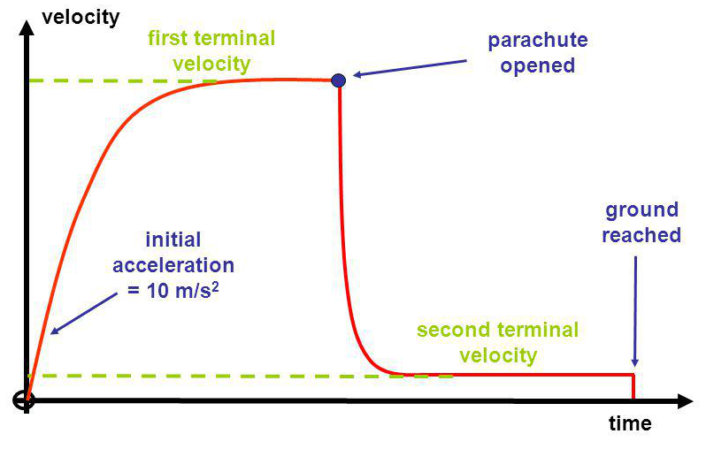
90 | State Newton's First Law: | An object at rest will remain at rest and a moving object will continue moving at constant velocity as long as no resultant force acts on the object.
91 | What is needed for velocity of an object to change? | An unbalanced/resultant force
92 | What is inertia? | The tendency of objects to continue in their state of rest or of uniform motion is called inertia.
93 | State Newton's Second Law: | The acceleration of an object is proportional to the resultant force  acting on the object, and inversely proportional to the mass of the  object.
94 | What is the word equation for Newton's Second Law? | $$\text{Resultant force = mass}×\text{acceleration}$$
95 | What is the symbol for proportionality? | ∝
96 | What is inertial mass? | A measure of how difficult it is to change the velocity of an object. It is defined as the ratio of force over acceleration.
97 | What is the symbol that indicates an approximate value or approximate answer? | ~
98 | State Newton's Third Law: | Whenever two objects interact, the forces they exert on each other are equal and opposite.
99 | What is the stopping distance of a vehicle? | It is the sum of the distance the vehicle travels during the driver’s reaction time (thinking distance) and the distance it travels under the braking force (braking distance).
100 | For a given braking force, how does stopping distance change with speed of the vehicle? | For a given braking force the greater the speed of the vehicle, the greater the stopping distance.
101 | What is a typical human reaction time? | 0.2 - 0.9 s
102 | What can affect a driver's reaction time? | Tiredness, drugs and alcohol. Distractions may also affect a driver’s ability to react.
103 | How can human reaction times be measured? | There are some computer programs which measure reaction times. Another method is to drop a ruler and compare where on the ruler it is caught.
104 | What factors may affect the braking distance of a vehicle? | The braking distance of a vehicle can be affected by adverse road and weather conditions (such as wet and icy) and poor condition of the vehicle (such as the brakes and tyres).
105 | What physical changes to the vehicle happen when brakes are applied? | When a force is applied to the brakes of a vehicle, work done by the friction force between the brakes and the wheel reduces the kinetic energy of the vehicle and the temperature of the brakes increases.
106 | In order to stop a vehicle within a certain distance, how does the speed of the vehicle affect the necessary braking force? | The greater the speed of a vehicle the greater the braking force needed to stop the vehicle in a certain distance.
107 | What are the dangers of large braking forces needed to slow down fast moving vehicles? | The greater the braking force the greater the deceleration of the vehicle. Large decelerations may lead to brakes overheating and/or loss of control.
108 | What is the word equation for momentum? | $$\text{momentum = mass × velocity}$$
109 | What is the symbol equation for momentum? | $$p = m v$$
110 | What are the units of momentum? | kg m/s
111 | What is the principle of conservation of momentum? | In a closed system, the total momentum before an event is equal to the total momentum after the event.
112 | What happens to momentum when a force acts on an object that is moving or able to move? | A change in momentum occurs, where the force is the rate of change of momentum.
113 | What is the word equation that dictates the change in momentum when a force is applied? | $$\text{Force }= \frac{\text{mass}×\text{change in velocity}}{\text{time taken}}$$
114 | What is the symbol equation that dictates the change in momentum when a force is applied? | $$F= \frac{m∆v}{∆t}$$
115 | What does an air bag have to do with the rate of change of momentum? | It increases the time over which the momentum changes to reduce the force on the passenger.

