1 | What are the two types of waves? | Transverse and longitudinal
2 | What is an example of a transverse wave? | Ripples on the surface of water
3 | What is an example of a longitudinal wave? | Sound waves travelling through air
4 | What are the differences between longitudinal and transverse waves? | In transverse waves, the direction that the wave travels is perpendicular to the direction of the vibrations. In longitudinal waves, the direction the wave travels is parallel to the direction of the vibrations.
5 | Draw a labelled diagram of a wave to demonstrate amplitude, wavelength, peaks, troughs and one complete cycle of a wave. | 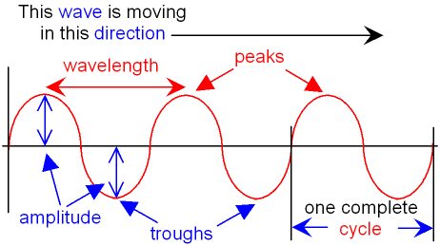
6 | What is the definition of amplitude? | The amplitude of a wave is the maximum displacement of a point on a wave away from its undisturbed position.
7 | What is the definition of wavelength? | The wavelength of a wave is the distance from a point on one wave to the equivalent point on the adjacent wave.
8 | What is the definition of frequency? | The frequency of a wave is the number of waves passing a point each second.
9 | What is the equation from the Physics equation sheet that relates period and frequency? | $$\text{period}=\frac{1}{\text{frequency}}$$
10 | What is the symbol equation from the Physics equation sheet that relates period and frequency? | $$T=\frac{1}{f}$$
11 | What are the units of frequency? | Hertz, Hz
12 | What is the wave speed? | The wave speed is the speed at which the energy is transferred (or the wave moves) through the medium.
13 | What is the word equation for wave speed? | $$\text{wave speed = frequency × wavelength}$$
14 | What is the symbol equation for wave speed? | $$v = f λ$$
15 | What are the units of wave speed? | metres per second, m/s
16 | What happens to waves at the boundary between materials? | They can be reflected, absorbed or transmitted.
17 | Draw a ray diagram to show how light is reflected by a plane mirror. | 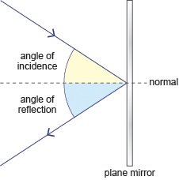
18 | What is the relationship between the angles of incidence and reflection. | Angle of incidence = angle of reflection
19 | How do sound waves travel through solids? | Vibrations in the solid cause the sound wave to travel.
20 | How do humans hear a range of sounds? | Within the ear, sound waves cause the ear drum and other parts to vibrate which causes the sensation of sound. The conversion of sound waves to vibrations of solids works over a limited frequency range. This restricts the limits of human hearing.
21 | What is the range of normal human hearing? | 20 Hz to 20 kHz
22 | What are ultrasound waves? | Ultrasound waves have a frequency higher than the upper limit of hearing for humans.
23 | How are ultrasound waves used for imaging? | Ultrasound waves are partially reflected when they meet a boundary between two different media. The time taken for the reflections to reach a detector can be used to determine how far away such a boundary is. This allows ultrasound waves to be used for both medical and industrial imaging.
24 | What are seismic waves? | Seismic waves are produced by earthquakes.
25 | What are P-waves? | P-waves are longitudinal, seismic waves. P-waves travel at different speeds through solids and liquids.
26 | What are S-waves? | S-waves are transverse, seismic waves. S-waves cannot travel through a liquid.
27 | What do P-waves and S-waves provide evidence for? | P-waves and S-waves provide evidence for the structure and size of the Earth’s core, which are not easily observable.
28 | How are waves used to detect objects in deep water and measure water depth? | Echo sounding, using high frequency sound waves
29 | What are electromagnetic waves? | Electromagnetic waves are transverse waves that transfer light energy from the source of the waves to an absorber.
30 | What are the groups of waves in the electromagnetic spectrum. Label increasing wavelength and frequency. | 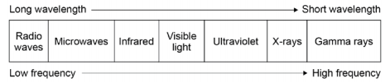
31 | Waves have different velocities in different substances. What effect does this lead to? | Refraction
32 | Draw a ray diagram to show how light is refracted at a surface between two materials. | 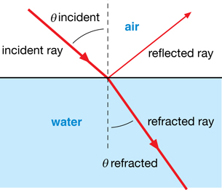
33 | Draw a wave front diagram to explain how refraction is related to the change of speed that happens when a wave travels from one medium to another. | 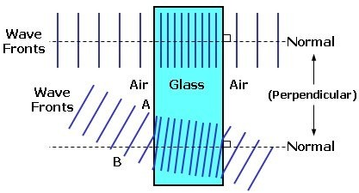
34 | In the required practical activity about infra-red variation, what is the independent variable? | The surface surrounding the heat source.
35 | How can radio waves be produced? | Oscillations in electrical circuits.
36 | How are radio waves related to alternating current? | When radio waves are absorbed they may create an alternating current with the same frequency as the radio wave itself, so radio waves can themselves induce oscillations in an electrical circuit.
37 | How are electromagnetic waves related to atoms and nuclei? | Changes in atoms and the nuclei of atoms can result in electromagnetic waves being generated or absorbed over a wide frequency range.
38 | Where do gamma rays originate from? | Changes in the nucleus of an atom.
39 | What is radiation dose? | Radiation dose is a measure of the risk of harm resulting from an exposure of the body to the radiation.
40 | What are the units of radiation dose? | Sieverts, Sv
41 | How many millisieverts (mSv) make up 1 sievert (Sv)? | 1000 millisieverts (mSv) = 1 sievert (Sv)
42 | What effect do ultraviolet waves have on skin? | They can cause it to age prematurely and they increase the risk of skin cancer.
43 | Which types of EM radiation are ionising? | X-rays and gamma rays
44 | What effects can ionising radiation have on the body? | They can cause mutation of genes and cancer.
45 | What are the uses of each type of EM radiation? | radio waves – television and radio • microwaves – satellite communications, cooking food • infrared – electrical heaters, cooking food, infrared cameras • visible light – fibre optic communications • ultraviolet – energy efficient lamps, sun tanning • X-rays and gamma rays – medical imaging and treatments
46 | How do convex lenses form an image? | In a convex lens, parallel rays of light are brought to a focus at the principal focus.
47 | What is the focal length? | The distance from the lens to the principal focus is called the focal length.
48 | What is a real image? | One that can be shown on a screen.
49 | What is a virtual image? | One that does not exist, and only appears to.
50 | What type of image does a convex lens produce? | Real or virtual
51 | What type of image does a concave lens produce? | Virtual
52 | What is the equation from the Physics equation sheet for magnification? | Magnification = image height / object height
53 | What are the units of magnification? | Magnification is a ratio and so has no units.
54 | How is a convex lens represented in ray diagrams?
55 | How is a concave lens represented in ray diagrams?
56 | What is the difference between the colours in the visible light spectrum? | They each have their own narrow band of wavelength and frequency.
57 | What is the word for reflection from a smooth surface? | Specular reflection
58 | What is the word for reflection from a rough surface? | Diffuse reflection
59 | How do colour filters work? | Colour filters work by absorbing certain wavelengths (and colour) and transmitting other wavelengths (and colour).
60 | What determines the colour of an opaque object? | The colour of an opaque object is determined by which wavelengths of light are more strongly reflected. Wavelengths that are not reflected are absorbed. If all wavelengths are reflected equally the object appears white. If all wavelengths are absorbed the objects appears black.
61 | What words are used to describe objects which transmit light? | Transparent or translucent
62 | All objects emit infrared radiation. The hotter the object… | the more infrared radiation it radiates in a given time.
63 | What is a perfect black body? | A perfect black body is an object that absorbs all of the radiation incident on it. A black body does not reflect or transmit any radiation. Since a good absorber is also a good emitter, a perfect black body  would be the best possible emitter.
64 | What can be said about the rate that an object absorbs and emits radiation? | A body at constant temperature is absorbing radiation at the same rate as it is emitting radiation. The temperature of a body increases when the body absorbs radiation faster than it emits radiation.
65 | What factors affect the temperature of the Earth? | The temperature of the Earth depends on many factors including: the rates of absorption and emission of radiation, reflection of radiation into space.

