1 | What are the poles of a magnet? | The poles of a magnet are the places where the magnetic forces are strongest.
2 | When two magnets are brought close to each other, what happens? | They exert a force on each other.
3 | What happens when two like poles of magnets are brought close to each other? | They repel each other.
4 | What happens when two opposite poles of magnets are brought close to each other? | They attract each other.
5 | What type of force is this an example of ? | A non-contact force.
6 | What is a permanent magnet? | One which produces its own magnetic field.
7 | What is an induced magnet? | An induced magnet is a material that becomes a magnet when it is placed in a magnetic field. Induced magnetism always causes a force of attraction. When removed from the magnetic field an induced magnet loses most/all of its magnetism quickly.
8 | What is the magnetic field? | The region around a magnet where a force acts on another magnet or on a magnetic material (iron, steel, cobalt and nickel).
9 | What type of force exists between a magnet and a magnetic material? | Attractive force
10 | What does the strength of the magnetic field depend upon? | The strength of the magnetic field depends on the distance from the magnet. The field is strongest at the poles of the magnet.
11 | How do we define the direction of the magnetic field? | The direction of the magnetic field at any point is given by the direction of the force that would act on another north pole placed at that point. The direction of a magnetic field line is from the north (seeking) pole of a magnet to the south(seeking) pole of the magnet.
12 | How does a magnetic compass work? | It contains a small bar magnet. The Earth has a magnetic field. The compass needle points in the direction of the Earth’s magnetic field.
13 | How can you use a compass to plot the magnetic field pattern of a magnet? | Place the compass in the field around the magnet. Draw a dot where the compass points.(North and South). Move the compass so that the South direction of the needle is at the dot you just drew. Repeat until the lines form a loop.
14 | Draw the magnetic field pattern of a bar magnet. Show how strength and direction of the field changes. | 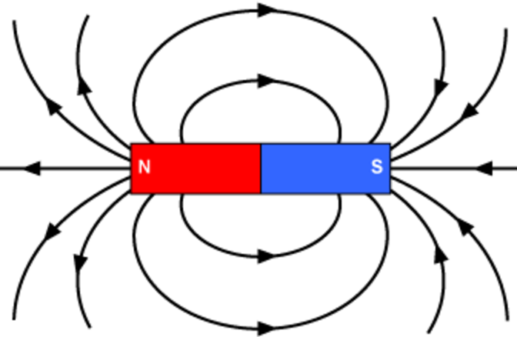
15 | When current flows through a conducting wire… | A magnetic field is produced around the wire. The strength of the magnetic field depends on the current through the wire and the distance from the wire.
16 | What is a solenoid? | Shaping a wire to form a solenoid increases the strength of the magnetic field created by a current through the wire. The magnetic field inside a solenoid is strong and uniform.
17 | How can the strength of a solenoid be increased? | By adding an iron core.
18 | What is an electromagnet? | It is a solenoid with an iron core.
19 | Draw the magnetic field pattern of a solenoid. | 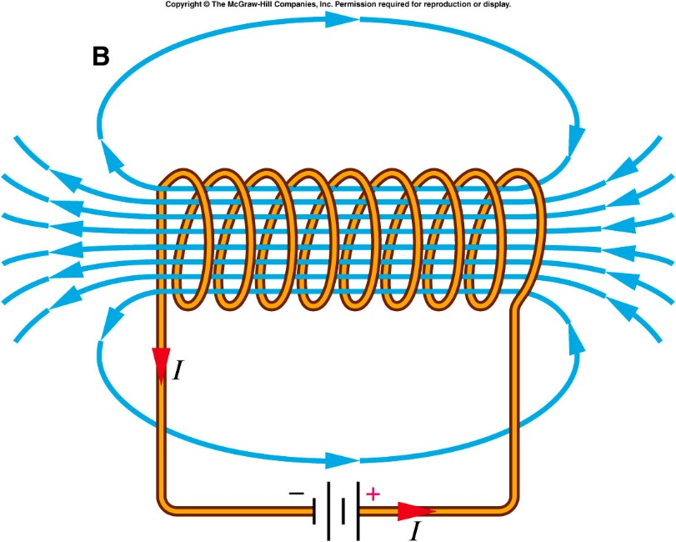
20 | Draw is the magnetic field pattern around a current carrying wire. | 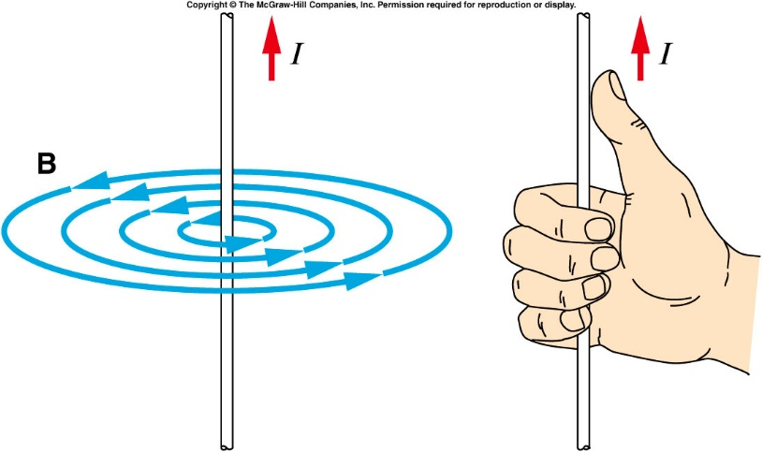
21 | What is the motor effect? | When a conductor carrying a current is placed in a magnetic field the magnet producing the field and the conductor exert a force on each other. This is called the motor effect.
22 | What does Fleming's left hand rule represent? | The relative orientation of the directions of the force, the current in the conductor and the magnetic field.
23 | What is the word equation from the Physics equation sheet that describes a conductor at right angles to a magnetic field and carrying a current? | $$\text{force = magnetic flux density × current × length}$$
24 | What is the symbol equation from the Physics equation sheet that describes a conductor at right angles to a magnetic field and carrying a current? | $$F = B I l$$
25 | What is the unit of magnetic flux density? | Tesla, T
26 | What happens to a coil of wire carrying a current in a magnetic field? | It rotates
27 | How do loudspeakers and headphones use the motor effect? | They convert variations in current in electrical circuits to the pressure variations in sound waves.
28 | What is the generator effect? | If an electrical conductor moves relative to a magnetic field or if there is a change in the magnetic field around a conductor, a potential difference is induced across the ends of the conductor. If the conductor is part of a complete circuit, a current is induced in the conductor. This is called the generator effect.
29 | How does an induced current that generates a magnetic field affect the original scenario? | It opposes the change that generated the field.
30 | What does an alternator use the generator effect for? | To generate AC
31 | What does a dynamo use the generator effect for? | To generate DC
32 | How do microphones use the generator effect? | Microphones use the generator effect to convert the pressure variations in sound waves into variations in current in electrical circuits.
33 | What does a basic transformer consist of? | A primary coil and a secondary coil wound on an iron core.
34 | Why is iron used as the core of a transformer? | It is easily magnetised.
35 | What is the equation from the Physics Equation Sheet which describes how the potential difference across coils relates to the number of turns on each coil. | $$\frac{V_{p}}{V_{s}}=\frac{N_{p}}{N_{s}}$$
36 | In a step-up transformer, which potential difference is greater? | V_{s}
37 | In a step-down transformer, which potential difference is greater? | V_{p}
38 | If transformers were 100% efficient, what would the electrical power output be? | It would equal the electrical power input.
39 | What is the equation from the Physics equation sheet that relates the power input and output of transformers? | $$V_{s}×I_{s} = V_{P}×I_{p}$$
40 | What are the units of power? | Watts, W

