**AQA Biology**

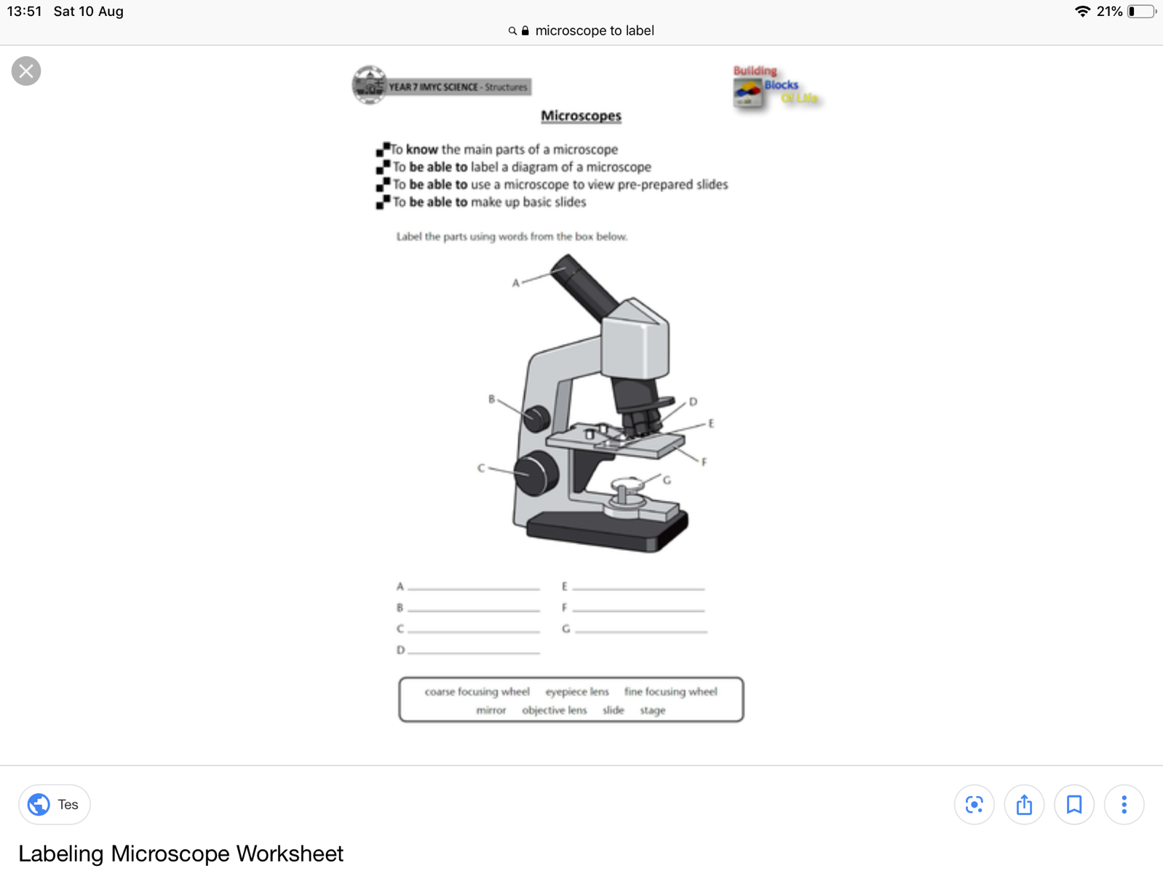**Required Practical 1- Microscopy**

**Formulae**

Total magnification=

Actual size=

**Glossary**

Microscopy:

Light Microscope:

Electron Microscope:

Magnification:

Resolution:

***Aims***:

* To use a light microscope to observe, draw and label biological specimens.
* To calculate magnification and actual size of specimens.

**Label the parts of the microscope A-G.**

1. Which part of the microscope would you use to focus the image?
2. Which part of the microscope would you use to see greater detail at a higher magnification?

**Method**

1. Use a dropping pipette to put a drop of water on the microscope slide
2. Peel off a thin layer of epidermal tissue
3. Use forceps to place thin layer on the microscope slide
4. Put 2 drops of iodine solution onto the tissue

**Iodine is a stain. Stains highlight objects in a cell by adding colour to them**, **allowing us to see further details inside the cell.**

1. Carefully lower the coverslip and use paper to soak any excess liquid
2. Place the slide on the stage and turn to the lowest power objective lens

**This is because the field of view with high power would be too small making it difficult to locate the cells**

1. Look through the eyepiece and slowly move the stage down using the coarse adjustment knob until the cells on the slide come into view.
2. Turn the fine adjustment knob to bring the cells into focus
3. If you need to see the slide with greater magnification, change to a higher-powered objective lens and refocus
4. Make a clear, labelled drawing of some cells, with the magnification used written next to your diagrams

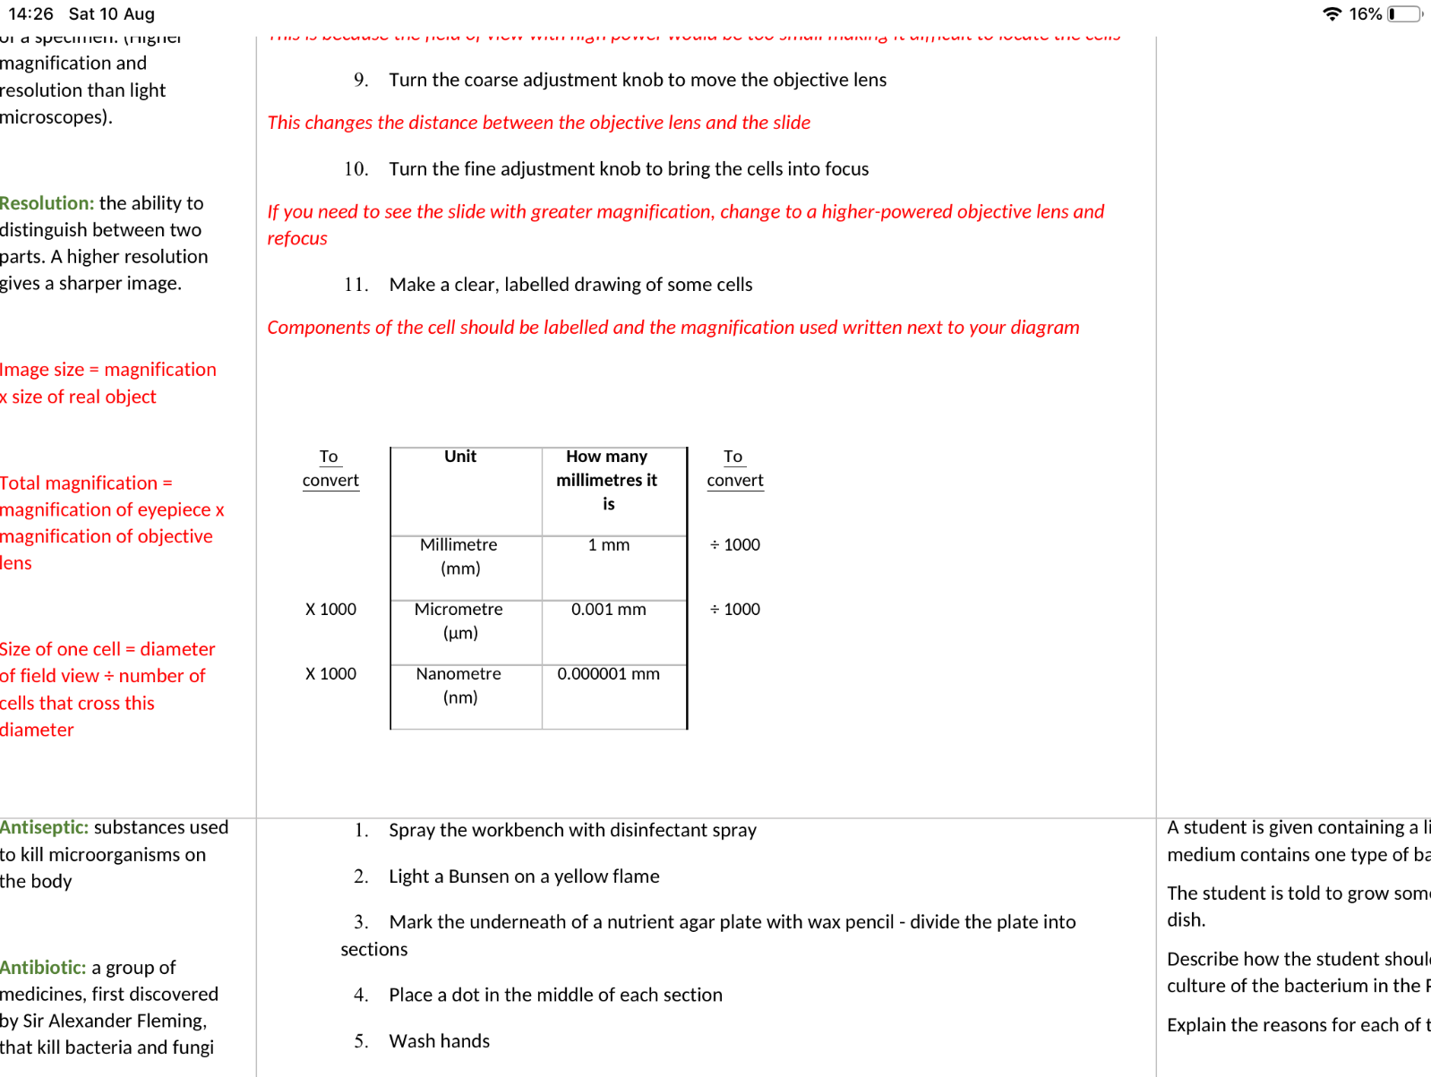

**Exam Question Practice**

1. Suggest why it is not possible to see the internal structures of a bacterial cell using a light microscope. (1 mark)
2. A student drew 3 images of a plant cell at 3 different magnifications. Match up the image letters to the correct objective lens.

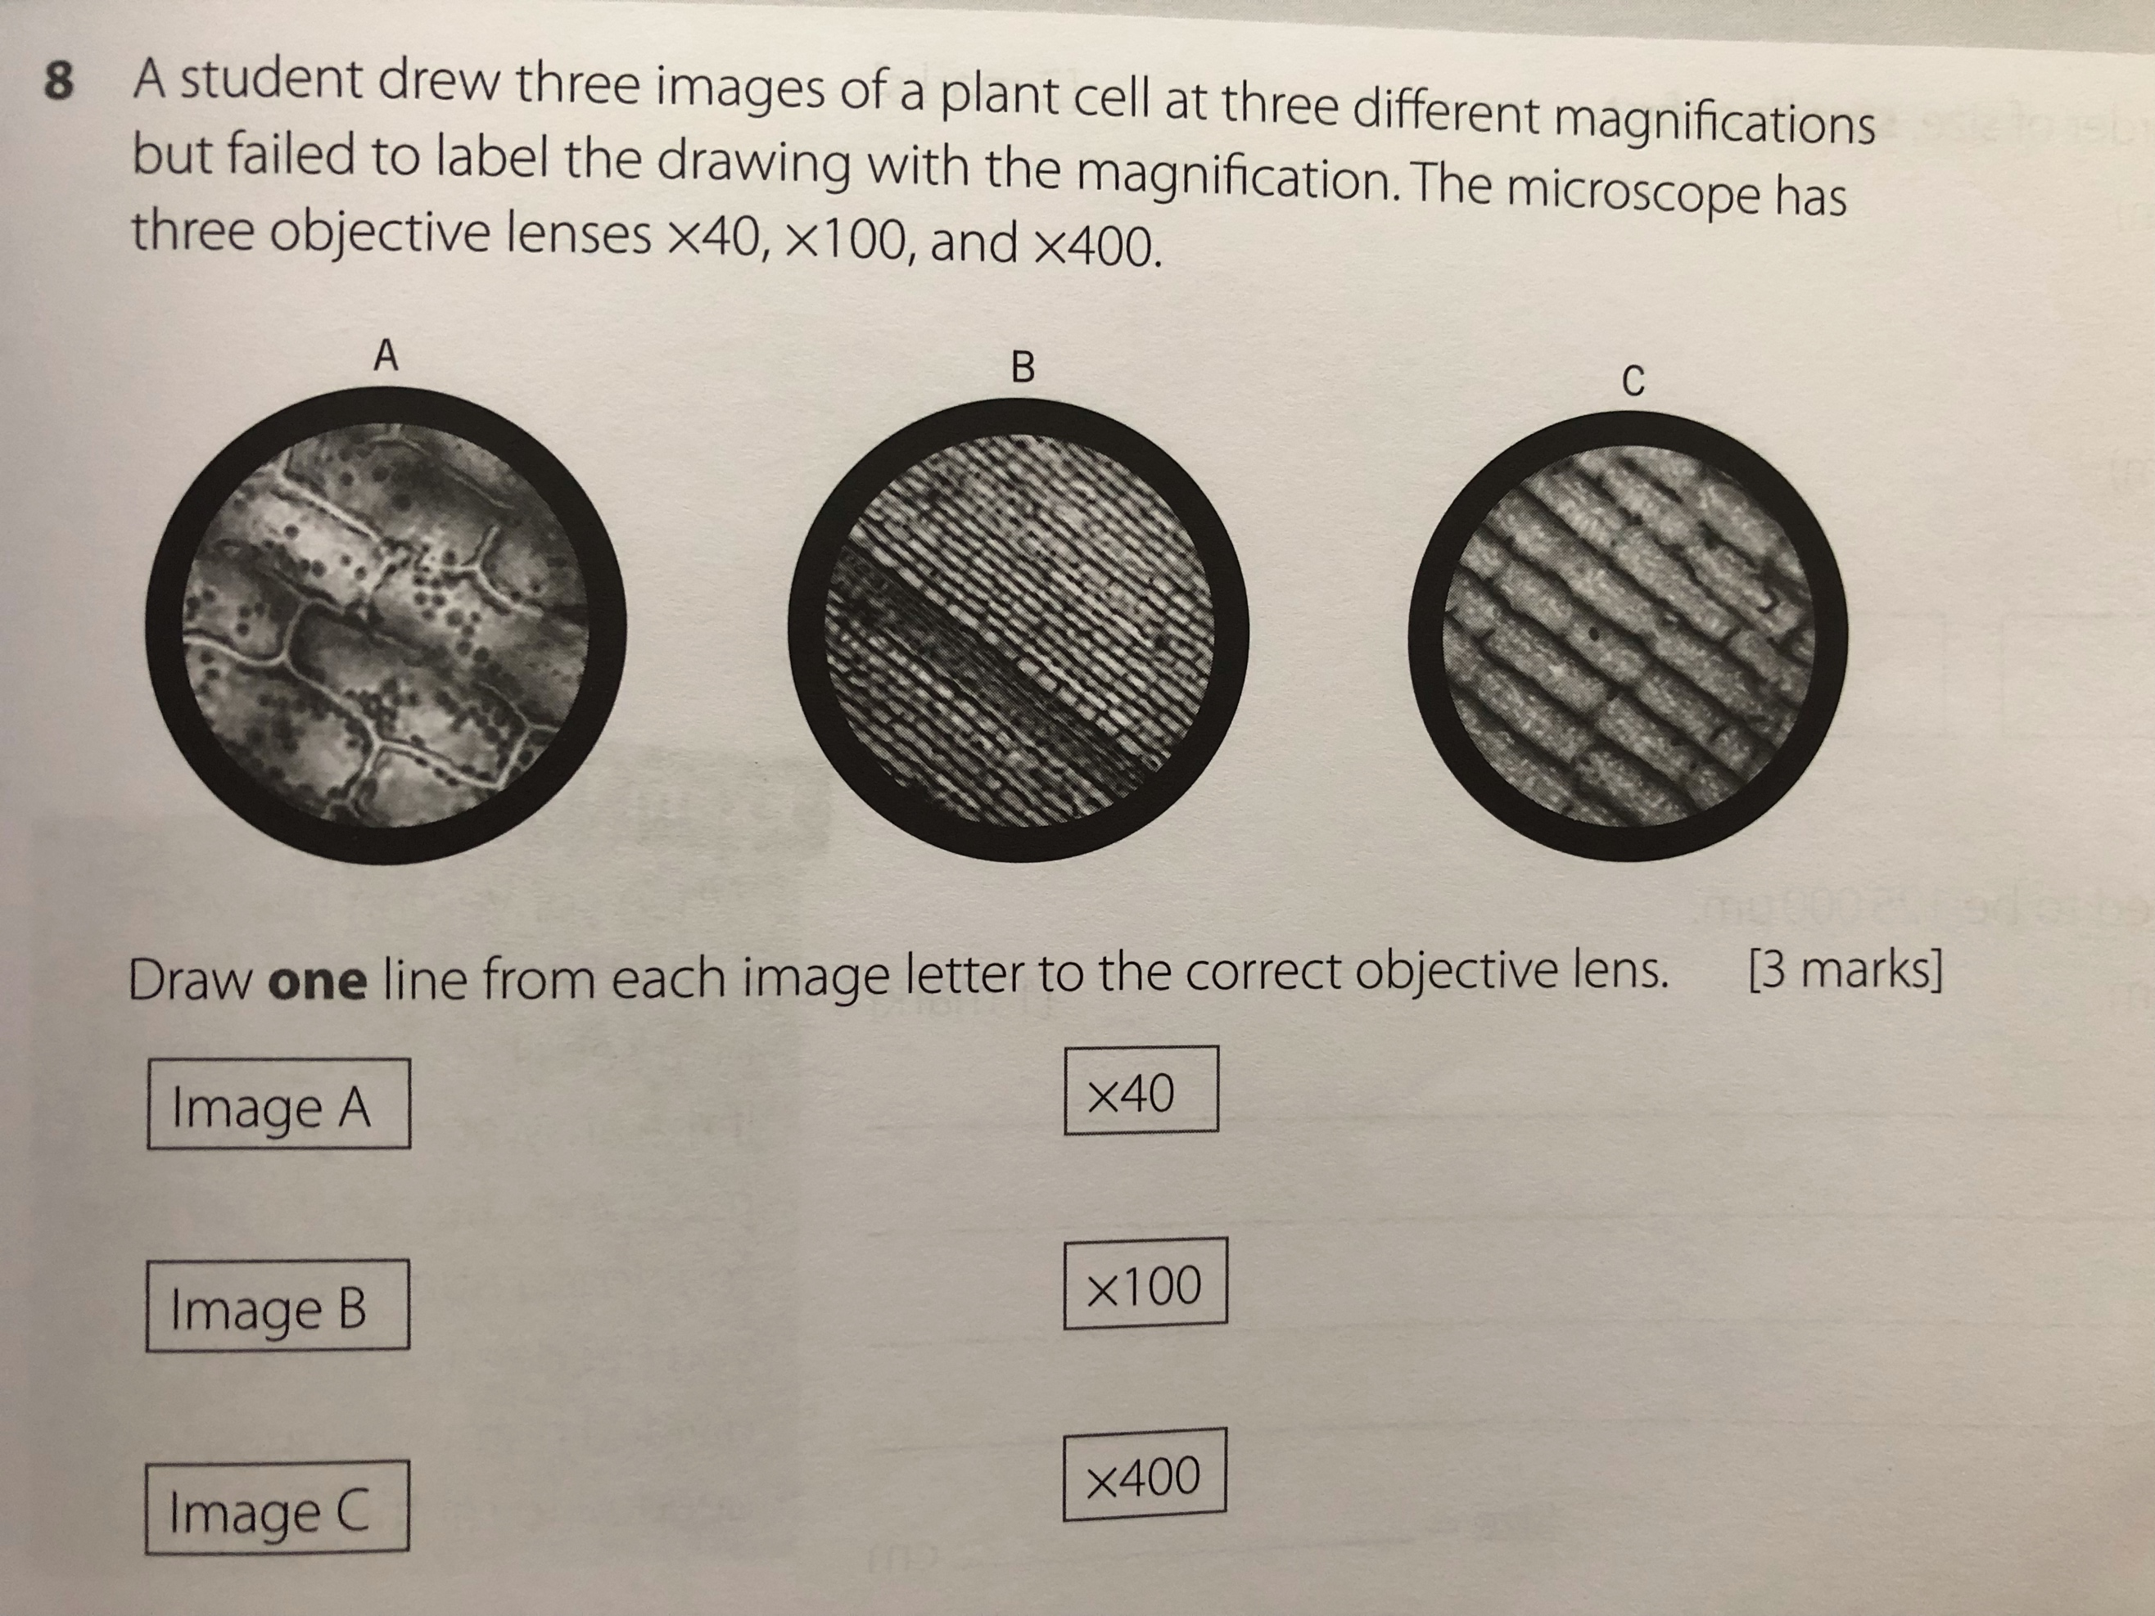

X40. X100. X400

1. A student views a sample using a x4 eyepiece and a x100 objective lens. They measure it to be 2cm long. Calculate the real size of the sample in um (3 marks)

……………………………………………………………………………………………………………………………………………………………………………………………………………………………………………………………………………………………………………………………………………………………………………………………………………..…………………………………………………………………………………………………………………………………………………………………………………………………………………………………………………………………………………………………………………………

Real size of sample =  **um**

**Drawing Cells: *Drawings must be drawn in pencil, use solid lines not sketched and be labelled.***

***Calculate the total magnification of the microscope you used and label onto your drawing.***