AQA Biology
Required Practical 6- Photosynthesis
Glossary

Photosynthesis-

Limiting Factor-

Anomalous-

Aims
- To investigate the effect of light intensity on the rate of photosynthesis.
- To accurately measure changes in the rate of photosynthesis.
- To describe how gas can be collected to provide results.
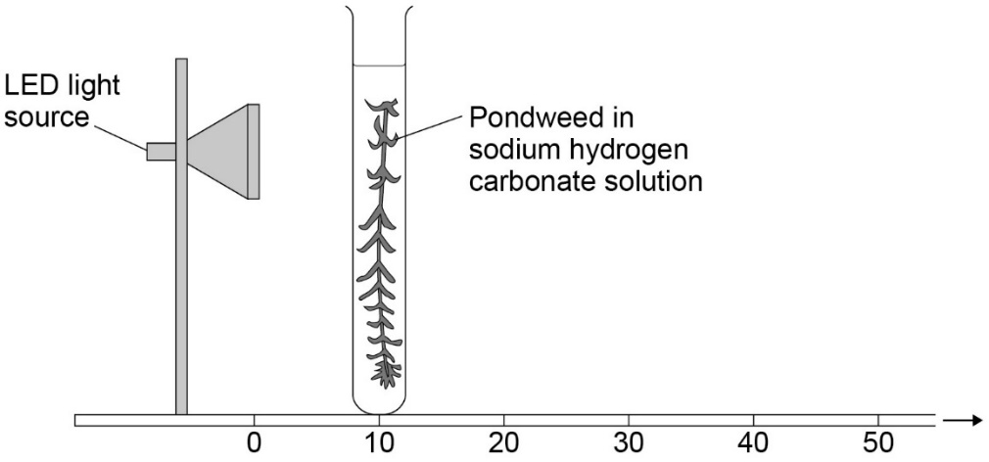

Knowledge Check

- Identify the dependent variable in this experiment.

………………………………………………………………………………………………………………………………………………………………………………………
- Write down the word equation for photosynthesis.

………………………………………………………………………………………………………………………………………………………………………………………

- Identify the gas in the bubbles produced at the cut end of the pondweed.

………………………………………………………………………………………………………………………………………………………………………………………

Method

- Set up a test tube rack at a distance of 10cm away from the light source
It is best to use an LED light source as they give off less heat. If a normal lightbulb is used it place a beaker of water in between the boiling tube and the lamp to reduce the temperature affecting the results.
- Fill a boiling tube with water and sodium hydrogen carbonate
This increases the concentration of CO2, stopping CO2 being a limiting factor
- Put a piece of pondweed into the boiling tube and leave for a couple of minutes
This is allow the pondweed to adjust to the new light intensity
- Start the stop watch and count the number of bubbles produced in 1 minute
- Repeat (use data to calculate a mean)
- Repeat at distances of 20cm, 30 cm and 40cm from the light source

This experiment can also be done with a capillary tube attached to collect the gas bubbles.

Results
Hint- Remember that anomalous results should NOT be included when calculating a mean.

Distance from light source (cm) | Number of gas bubbles released per minute
 | Test 1 | Test 2 | Test 3 | Mean
10
20
30
40
50
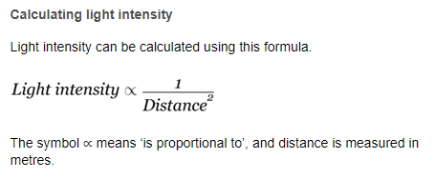
Higher: Explain the inverse square law.

Exam Practice

- Give the name of the structure in plant cells where photosynthesis takes place. (1 mark)

- Describe 2 control variables for this investigation and how you will control them. (2 marks)

………………………………………………………………………………………………………………………………………………………………………………………………………………………………………………………………………………………………………………………………………………………………………..
………………………………………………………………………………………………………………………………………………………………………………………………………………………………………………………………………………………………………………………………………………………………………..

- Describe how a student could change the method to investigate the effect of carbon dioxide Concentration on the rate of photosynthesis. You should include:
- How to change the independent variable
- Two control variables. (3 marks)

………………………………………………………………………………………………………………………………………………………………………………………………………………………………………………………………………………………………………………………………………………………………………..
………………………………………………………………………………………………………………………………………………………………………………………………………………………………………………………………………………………………………………………………………………………………………..

